**Assignment 1 |** Lower Secondary

Stage (6-8)

1st Semester | 2023-2024

|  |  |
| --- | --- |
| **Subject:** ICT | **Chapter:** 3 |
| **Objectives: Find the program Input, process and output /write a python program.** | |

Write a python program to do each of the following:

* Input your name
* Print “Hi “, Name
* Input your mass (KG)
* Calculate your weight on the Earth: WEarth= M*9.81
* Calculate your weight on the Moon: WMoon= M*1.622
* Print weight on Earth
* Print weight on Moon

Use Python to type the program and then write the program in the box below:

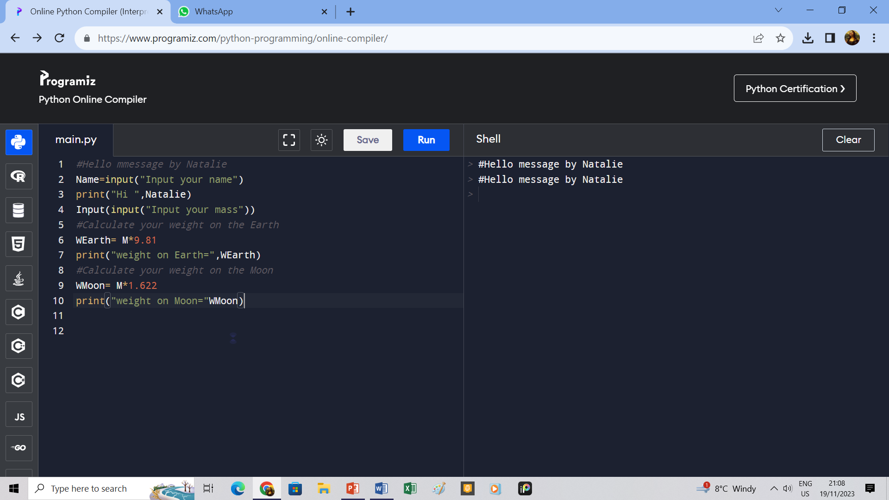

Save your file and upload it on LMS.

Save the Python file and upload it on LMS.