Maha Haddad 6F

Scratch Assignment

Code for Balloon:

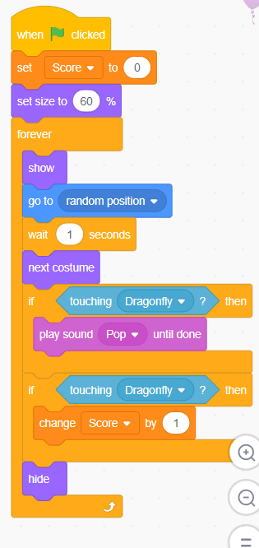

Code for Dragonfly:

