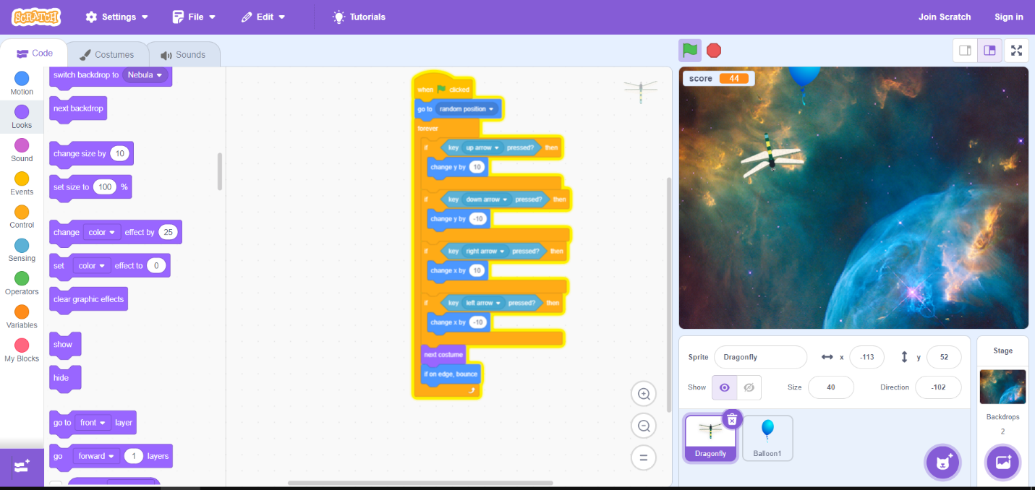Sufian Bibi

Grade 6 G