Nadia Bro

6F Scratch task

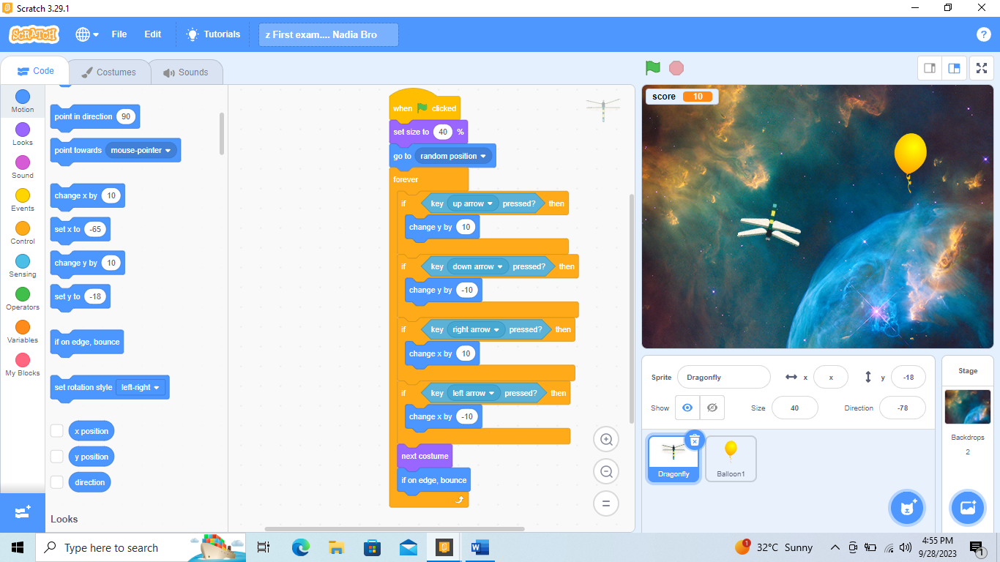

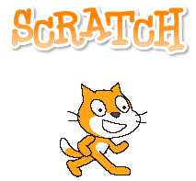

[This Photo](https://auka6.blogspot.com/p/scratch.html) by Unknown Author is licensed under [CC BY-SA-NC](https://creativecommons.org/licenses/by-nc-sa/3.0/)

