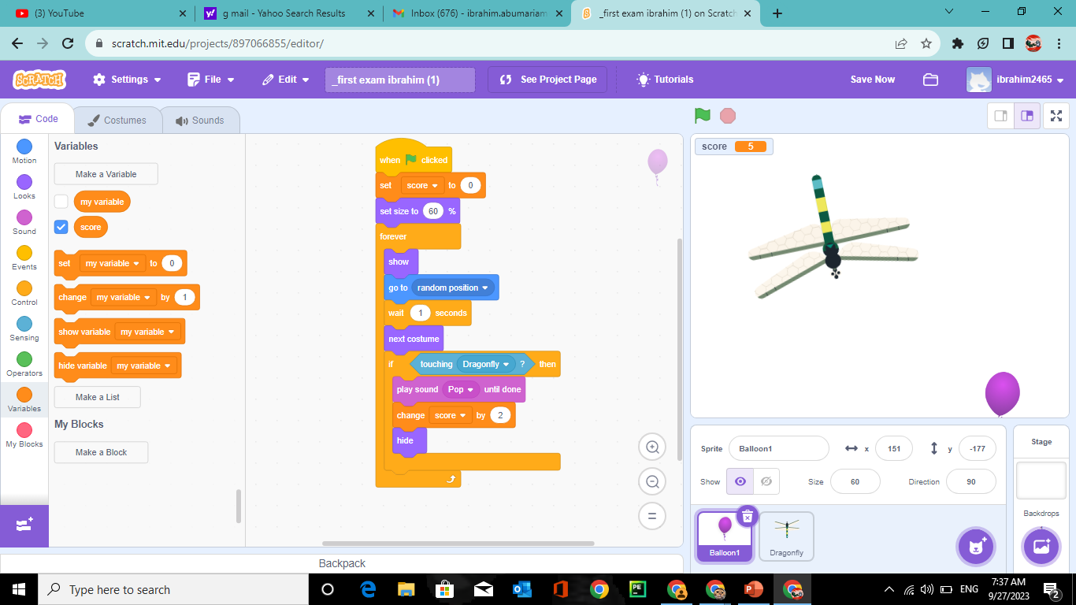

Ibrahim abumariam 6d

