**Date: 28-09-2023**

**Name: Maya O. Abdul-Razik.**

**Class: 6E**

**Balloon sprit**

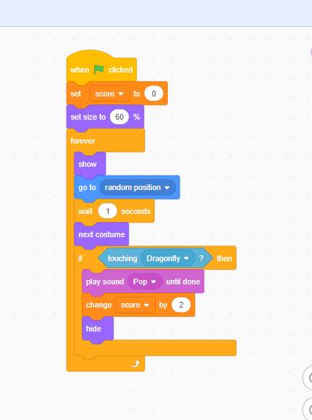

**Dragonfly sprit**

