**Assignment 1, Calla Malky- 6G**

**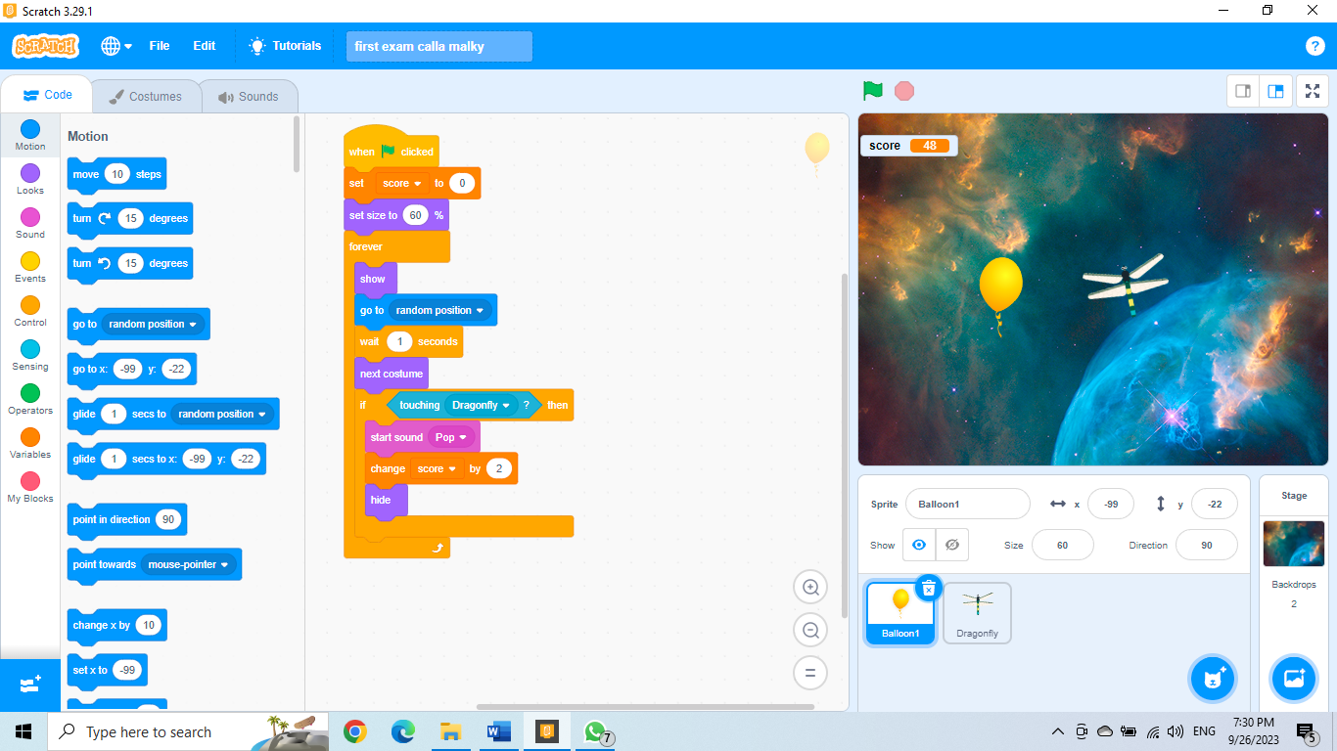***Balloon:*

*Dragonfly:* 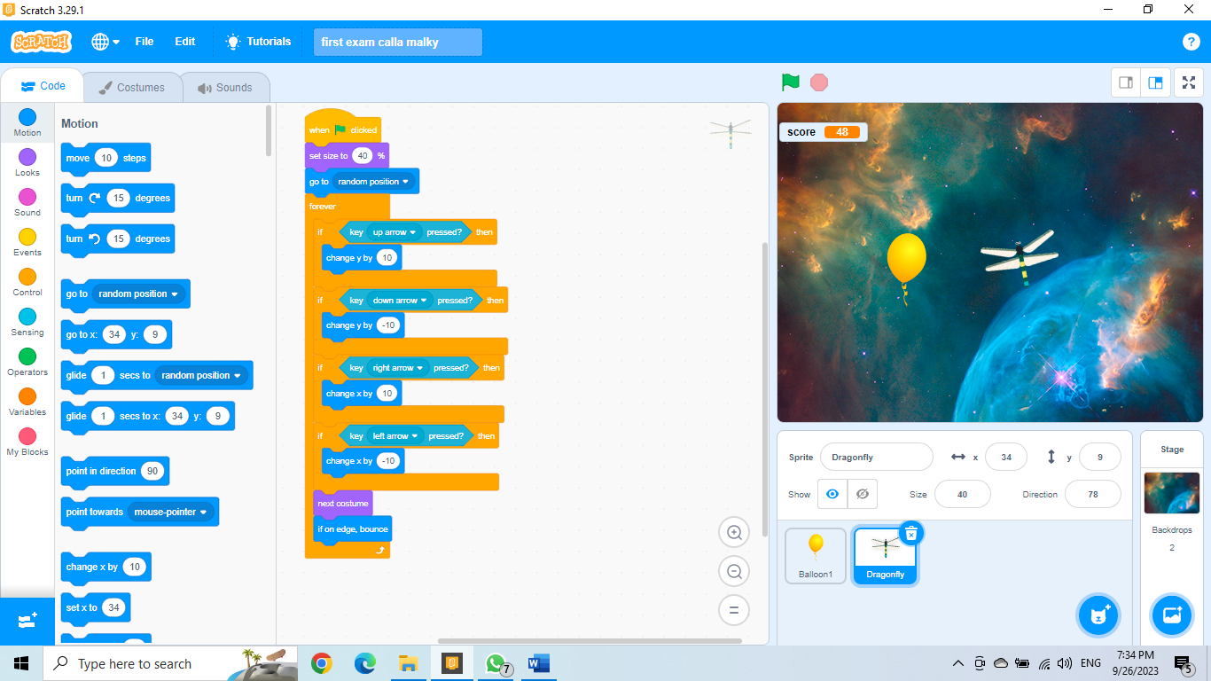

**Thank you Miss Samar**