**Zeena Qutaishat**

**6 c**

**Balloon Sprite**

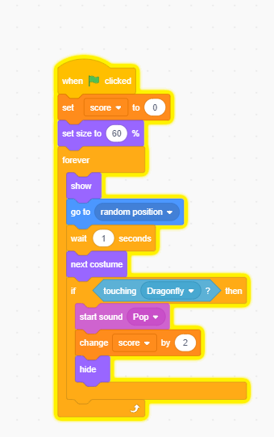

**Dragonfly Sprite**

