Assignment #1 | The Lower Secondary of Stage (6-8)
1st Semester | 2023-2024
Natalie Mansour 7a
Subject: ICT | Chapter: 2
Objectives:
- Design a form
- Recognize the safe website

Design a form
Imagine you have designed a new website about your preferred computer game.
Your website has a chat room so that friends can discuss the game and share tips on how to play.
What information will you collect from your friends when they register?
- Their name
- Their birth date
- Their last name
- Their email
Design a registration form to use on your website for registration, taking into consideration to add a star for the required fields.
Welcome to Roblox

Please enter this registration form

Your name:
Your last name:
Your email:
Your birth date:

Secure website
Is the following considered secure website, explain why?
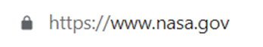

Yes it is a safe website, because it has a lock beside the website name

