Henry Habash

Grade: 6 E

**Dragon Fly Chasing Balloon Game**

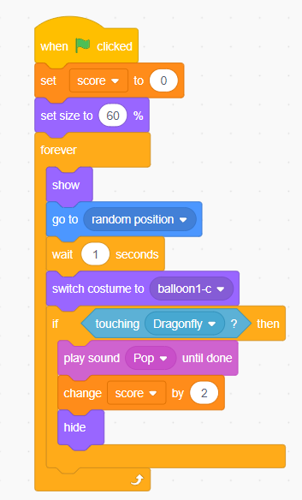

ballon

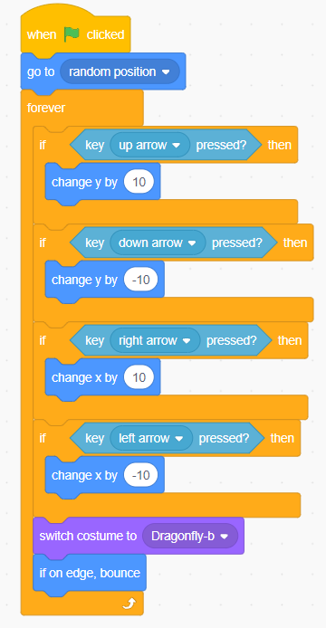

dragonfly