**Assignment #1** **|** The Lower Secondary of Stage (6-8)

1st Semester | 2023-2024

|  |  |
| --- | --- |
| **Subject:** ICT | **Chapter:** 2 |
| **Objectives:**   * Design a form * Recognize the safe website | |

**Design a form**

Imagine you have designed a new website about your preferred computer game.

Your website has a chat room so that friends can discuss the game and share tips on how to play.

What information will you collect from your friends when they register?

1. username
2. password
3. confirm password
4. email / phone number

Design a registration form to use on your website for registration, taking into consideration to add a star for the required fields.

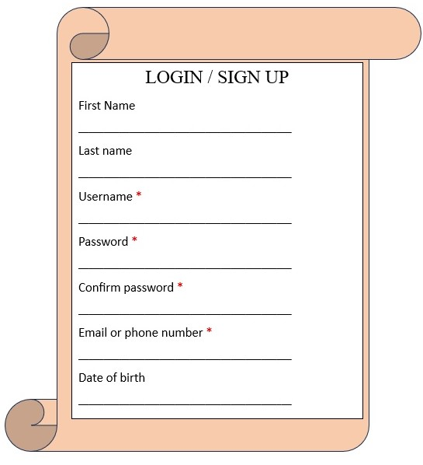

**Secure website**

Is the following considered secure website, explain why?



Yes, because it has a padlock symbol, which means it’s safe. Also, the https URL means that it is encrypted and that data cannot be sent over the internet.