**Play Safe, Be Safe, Have Fun**

**CHOOSE** age appropriate Games

**SET A TIME LIMIT** for video games. Agree to rules set up by parents

**DO NOT SHARE PERSONAL INFO**:

* Name/Password. 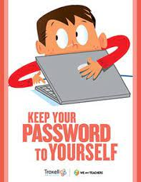
* Address.
* Phone Number.
* School Name.
* Pictures.

DON’T CLICK on Pop-Up or ads or unknown website. It may contain virus.

TELL your parents if you are upset by language, pictures or anything scary.

**SHARE GAME WITH PAREENTS** to guide you and ensure safety

hare