Daniel Janho 6G

Dragon fly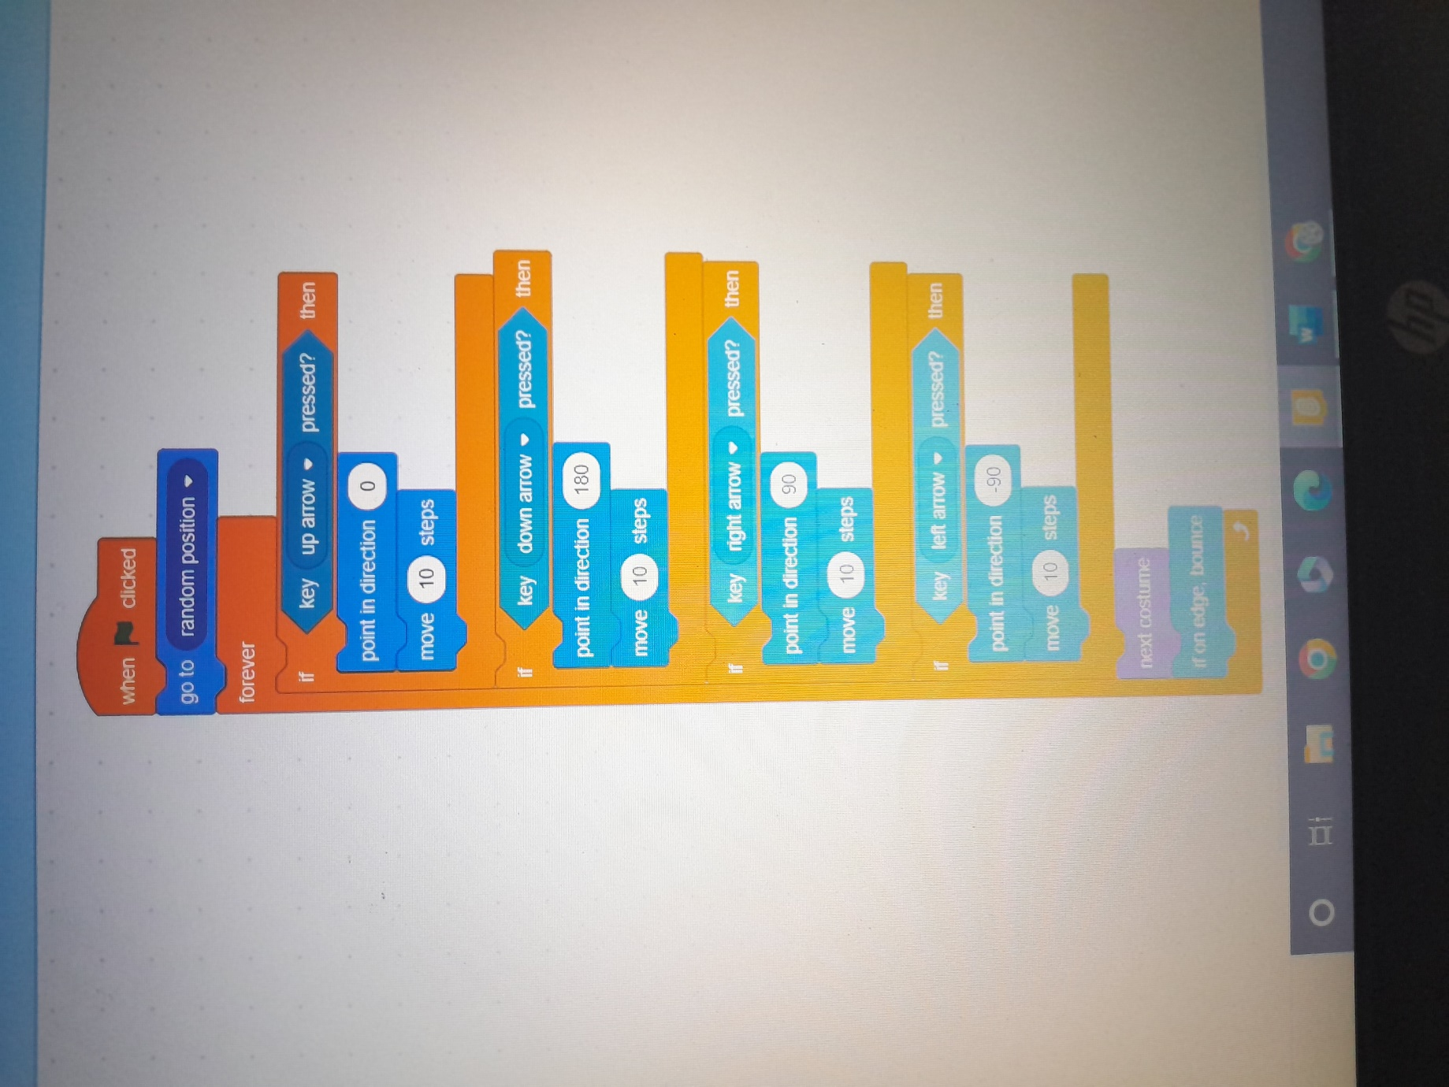

Balloon