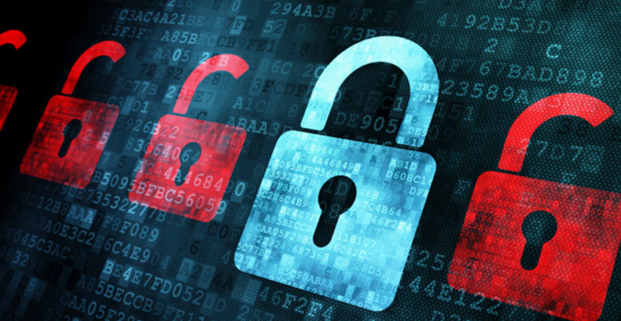  How to protect yourself from phishing?  - Protect your computer by using  security software.  - Protect your cell phone by  setting software to update  automatically.  - Protect your accounts by using  multi-factor authentication.  - Protect your data  by backing it up. | Phishing  What is Phishing?  Phishing is a type of social Engineering and  cybersecurity attacks where the attacker  impersonates someone via email or other  electronic communication methods,  including social networks and Short  Message Services (SMS) text messages,  to reveal sensitive information. | What is the effect of Phishing?  Phishing is the most common form of  cybercrime, with an estimated  3.4 billion spam emails sent  every day. The use of stolen  credentials are the most  common cause of data breaches.  Google blocks around 100 million  phishing emails daily.  PHISHING SAFETY TIPS 1. THINK BEFORE YOU CLICK 2. PRACTICE SAFE BROWSING 3. BE CAREFUL OF WHAT YOU DOWNLOAD  

