**BE SAFE:**

* **LOCK YOUR COMPUTER WHEN WALKING AWAY**
* **ALWAYS REMEMBER TO LOGOUT WHEN FINISHED**
* **NEVER LEAVE YOUR LAPTOP UNATTENED**

**CYBER CRIME AWARNESS**

**PASSPHRASES**

Choose a strong passphrases change them regularly, and NEVER share them with ANYONE



**WIRELESS SECURATY**

Know your network identity thieves prey on public and unprotected Wi-Fi networks



**PHISHING**

Don’t be a phishing scam victim.

Reputable organizations will never ask for personal data or passwords via email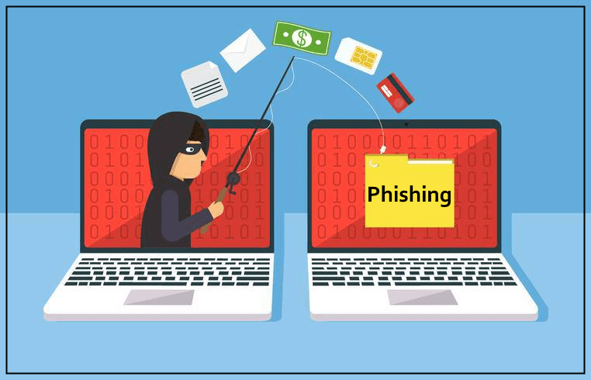

**COPYRIGHT**

Get the facts on sharing and downloading online.

It’s your job to endure sharing legally.



**FIRE WALLS**

A firewall is your computers first line of defense. Ensure you enable it



**SECURITY SOFWERE**

Install antivirus and anti-spyware softwhere software. Update regularly

