Online Danger

The internet is a big world , and there is a-lot of scammers ,hackers , viruses etc. and there is so many ways to prevent all of that.

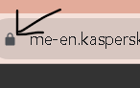 First of all never trust any-one online and don’t give anyone your personal information such as your telephone number ,email password ,credit card number all of that And don’t trust any website that does not have the lock symbol beside it .

And there is something called cookies on your laptop that saves the research so that it could show you stuff you are interested in ,but sometimes the cookies places the research to the wrong user and in that case they can easily hack your account .