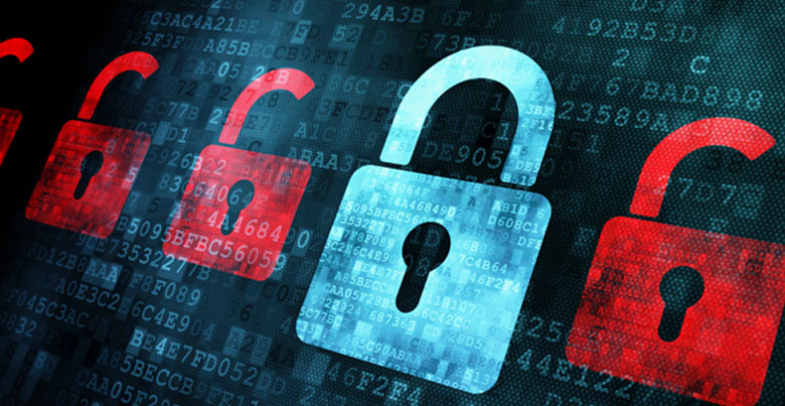  How to protect yourself from phishing?  - Protect your computer by using security  software.  - Protect your cell phone by setting software  to update automatically.  - Protect your accounts by using multi-factor authentication.  - Protect your data by backing it up.  What is the effect of Phishing?  Phishing is the most common form of  cybercrime, with an estimated 3.4 billion spam  emails sent every day. The use of stolen credentials is  the most common cause of data breaches.  Google blocks around 100 million phishing  emails daily. | Phishing  What is Phishing?  Phishing is a type of social  Engineering and cybersecurity  attacks where the attacker  impersonates someone via email or other  electronic communication  methods, including social  networks and Short Message  Service (SMS) text messages,  to reveal sensitive information. | PHISHING SAFETY TIPS 1. THINK BEFORE YOU CLICK 2. PRACTICE SAFE BROWSING 3. BE CAREFUL OF WHAT YOU DOWNLOAD  This Photo by Unknown Author is licensed under CC BY

