New opening in Khalda !!!

RAFI S HOT DOG STAND!!

Get Free Cola in every meal

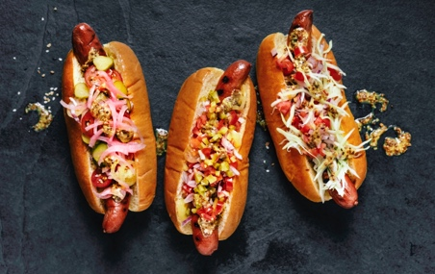 Tel:079332457