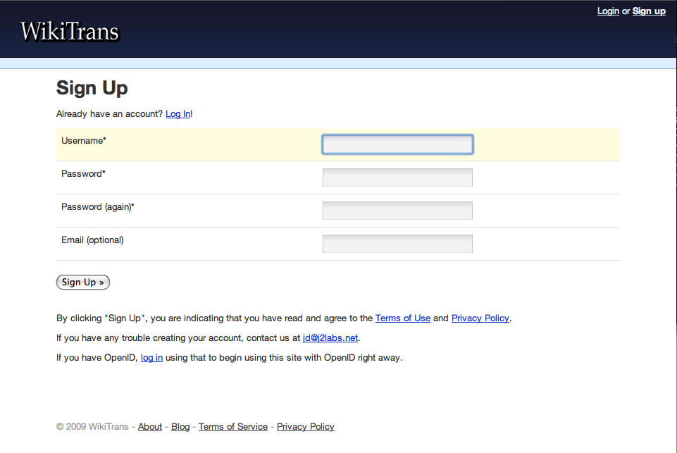To access this web site

U need to sign up for a

Membership u have to

Complete the following

Steps if u want to continue

Kindly press the next sign

U have to input a username

And your email or your phone number

We have a lot of offers to buy we give

7 days free trial to new members

Then u will have to buy it now

The offers are 3.99 for 1 month

9.99 For 5 months 84.99 for 18 months