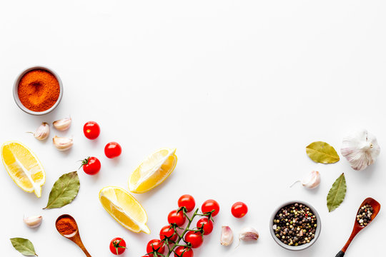1e1e8fbfed3d555c052154b6bad2c05c.jpgfffff.jpg

Continue with Email

Continue with Apple

Continue with Facebook

Continue with Google

**Login or create an account**