**Most plants can move but some of them are unique and can move some parts like their leaves.**

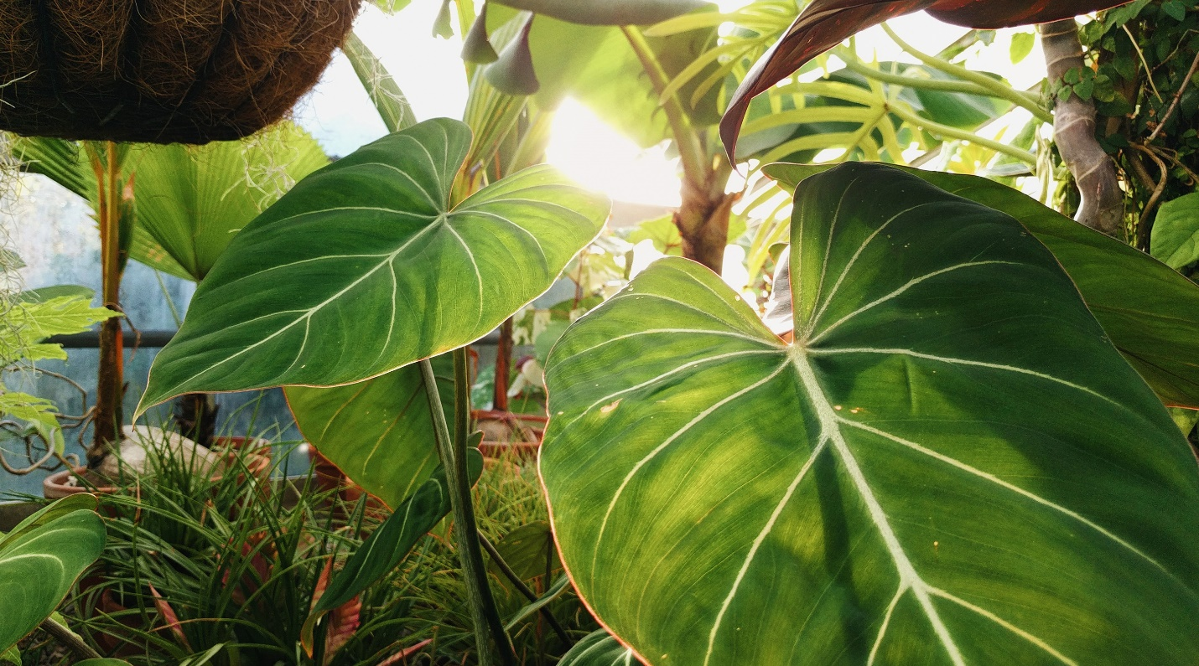

**Today we will talk about three plants that move.**

1. **Venus Flytrap**

**The Venus flytrap is a carnivorous plant that can eat insects by closing and opening its mouth it is found in north and south Carolina.**

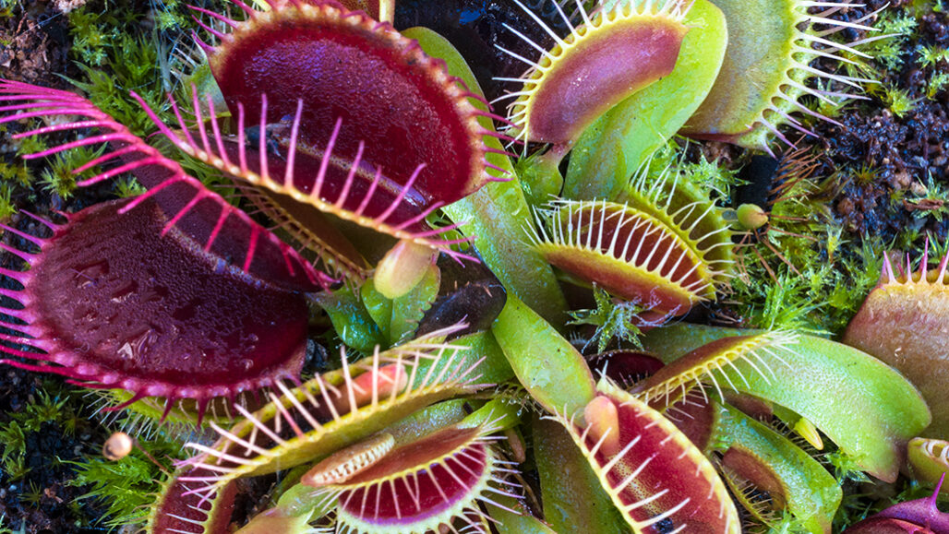

## 2. Bladderwort

**The bladderwort has a trap faster than the blink of an eye. It uses powerful suction to snatch its prey and puts their prey in their stomach.** **It is found in lakes, interdunal ponds, wet marshes, and rivers and streams.**

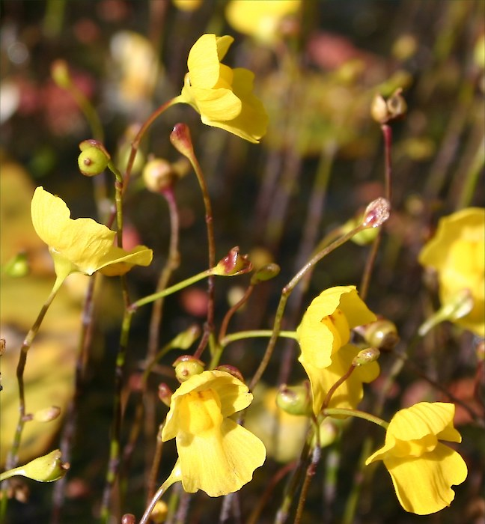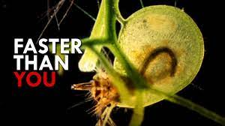

## 3. Dancing Plant

## Yes, there is a plant called as dancing plant. It has another name also, the telegraph plant. The scientific name of this plant is codariocalyx motorius. It is a tiny shrub with long slender leaves. It produces small purple colored flowers. These plants are commonly found in Asian countries.

## Resources used:

## <https://www.britannica.com/plant/Venus-flytrap>

## <https://www.progardentips.com/plants-that-can-move/>

## <https://www.sciencedaily.com/releases/2016/01/160129134331.htm>

## <https://sciencekids.in/amazing-dancing-plant-facts/>

## Buy SUPER TOY Dancing Cactus Talking Plush Toy with Singing & Recording Function - Repeat What You Say - Pack of 1, Rechargeable Cable Included Online at Low Prices in India - Amazon.in

**Thank you for listening**