**Biology lab report**

The effect of temperature on the diffusion of the dye found in beetroot

**Research question**:

What is the effect of the temperature (0,25,40) on the permeability of the membrane of the dye found in beetroot measured by absorption using a colorimeter?

**Scientific background**:

The diffusion of dye in beetroot is a process that can be affected by temperature. The dye in beetroot is primarily located in the vacuoles of the beetroot cells. When the beetroot is subjected to different temperatures, it can influence the rate of diffusion of the dye across the cell membranes and into the surrounding solution.

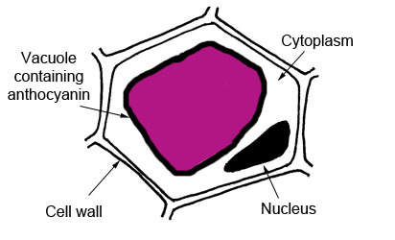figure 1: vacuoles of beetroot cells.

At higher temperatures, the molecules in the beetroot cells and the surrounding solution have higher kinetic energy. This increased kinetic energy leads to faster movement of the dye molecules, which enhances the rate of diffusion. The increased molecular motion results in more frequent collisions between the dye molecules and the cell membrane, promoting the passage of dye molecules through the membrane and into the surrounding solution.

Conversely, at lower temperatures, the kinetic energy of the molecules decreases, leading to slower movement and reduced collisions between dye molecules and the cell membrane. This decrease in molecular motion hinders the diffusion process, resulting in a slower rate of dye release from the beetroot cells.

Additionally, temperature can affect the fluidity of the cell membrane. At higher temperatures, the lipid bilayer of the cell membrane becomes more fluid and permeable, facilitating the diffusion of the dye molecules. On the other hand, at lower temperatures, the cell membrane becomes less fluid and rigid, which can impede the diffusion process.

It is important to note that extremely high temperatures can denature proteins and disrupt cell structures, potentially leading to cell membrane damage. This can affect the diffusion of the dye by altering the permeability of the cell membrane.

In summary, temperature plays a significant role in the diffusion of dye in beetroot. Higher temperatures increase the kinetic energy, promote molecular motion, enhance collisions, and increase the permeability of the cell membrane, leading to faster diffusion. Lower temperatures have the opposite effect, slowing down the diffusion process. However, extreme temperatures can have adverse effects on cell structures, which may affect the overall diffusion process.

**Hypothesis:**

As the temperature increases the permeability of the membrane increases.

Increasing temperature causes phospholipids in the cell membrane to gain kinetic energy, leading to enhanced fluidity and increased permeability. This allows molecules, including the dye, to pass through the membrane more easily, resulting in higher permeability at elevated temperatures.

**Manipulating the variables:**

Independent variable: Temperature, Celsius

Dependent variable: The absorption of dye

|  |  |  |
| --- | --- | --- |
| Controlled Variable | How will you keep this controlled? Stating the values and the equipment that you will be using | How could it affect your results if not controlled? |
| Size of beetroots | By using a cork borer, we can measure equal lengths of beetroots. | If not controlled it won’t be a fair and equal experiment and it will give inaccurate results. If the size is bigger there will be a greater amount of diffusion, and if the size is smaller, it will have a less amount of diffusion. Therefore, the size of the beetroots should be controlled. |
| Amount of water | By using a measuring cylinder, we can measure the exact amount of water. | By increasing the amount of water, it will dilute the concentration and not give accurate results. Therefore, you are supposed to put equal amounts of water to get accurate results. |
| Time | Using a stopwatch, we can calculate the exact equal time for each experiment | By leaving the beetroot in for a longer time, it allows more dye to diffuse. Therefore, you should leave them all in for a equal time, so they have the same amount of time to diffuse. |

Table 1: controlled variables.

5) materials and method:

Materials:

1. water baths pre-set at required
2. temperatures
3. thermometer
4. distilled water
5. syringe
6. large beetroot
7. cork borer
8. ruler
9. white tile
10. test tubes
11. colorimeter
12. knife
13. labels or pens for labelling
14. measuring cylinder

method:

1. Prepare 3 water baths pre-set to a range of temperatures between 0 °C and 40.

2. Use a measuring cylinder to add distilled water to 3 test tubes. Label each test tube with a temperature from the pre-set range.

3. Place each tube in the water bath set to the corresponding temperature for 5 minutes.

4. Check the temperature of each bath is correct using a thermometer. It is unlikely to be exactly the desired temperature. Record the actual temperature and use this in your table and graph.

5. Cut 3 beetroot cylinders using a cork borer. Using a knife, ruler and white tile, trim them all to the same length. Wash the cylinders thoroughly with water until the water runs clear and pat dry gently with a paper towel.

6. Add one beetroot cylinder to each of the 3 tubes and leave in the water bath for your desired time.

7. Shake the tubes once. Working quickly, use forceps to remove the cylinders carefully from each tube. Discard the cylinders, keeping the liquid. It may be easier to pour the liquid into clean test tubes.

8. Set the colorimeter to a blue/green filter and percentage transmission. Zero the colorimeter using a blank cuvette filled with distilled water.

9. Transfer liquid from each test tube in turn into a colorimeter cuvette, place into the colorimeter and read the percentage transmission reading, recording your results in a suitable table.

10. Plot a graph of transmission against temperature

6) Safety, Ethical and Environmental issues

Safety:

Glassware precautions: Handle glassware with care and caution to avoid breakage and injuries.

Sharp tool precautions: handle scalpels with care and caution to prevent injuries.

Hot water precautions: Handle boiling water with care and caution to prevent injureis

Ethical:

No animals were used; no plants were wasted.

Environmental:

beetroot was used as fertilizer in soil.

7) Results

|  |  |
| --- | --- |
| Temperature | Each beetroot had different shades of color for each temperature it was set in. |

Table one: qualitative data

|  |  |
| --- | --- |
| Temperature C | Absorbance |
| 0 degrees | 0.49 |
| 25 degrees | 0.45 |
| 40 degrees | 0.46 |

Table two: raw data.

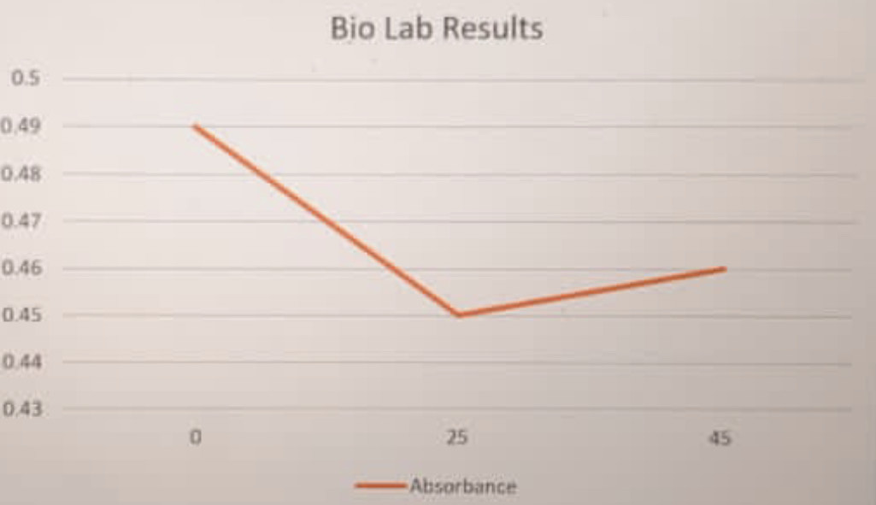

Graph 1: processed data