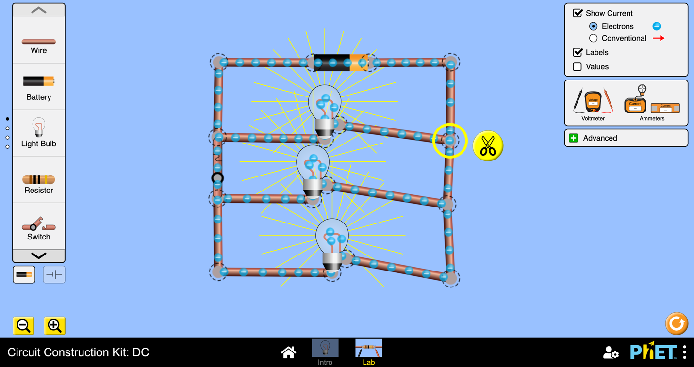

***Kitchen***



***Living room***

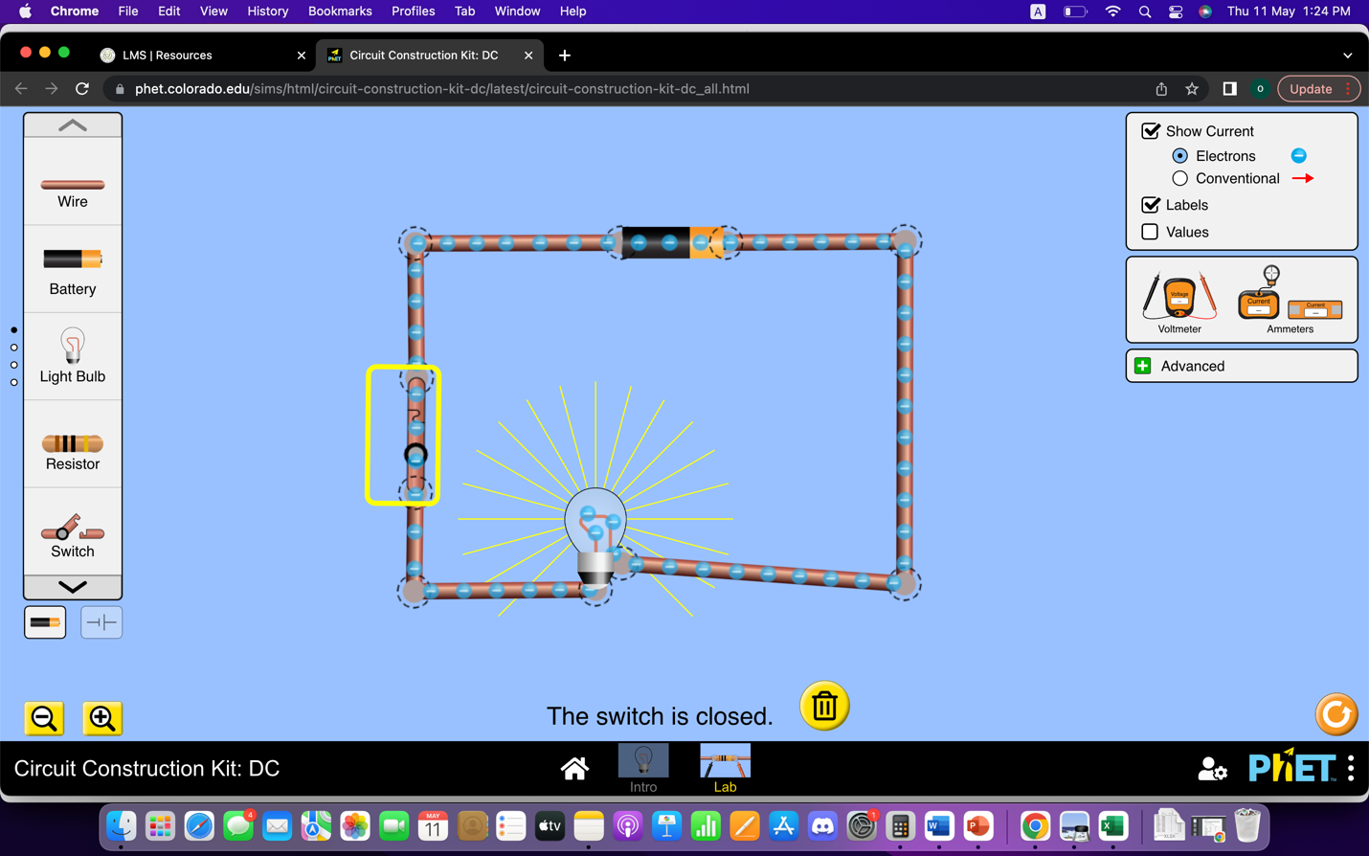

***Bathroom***

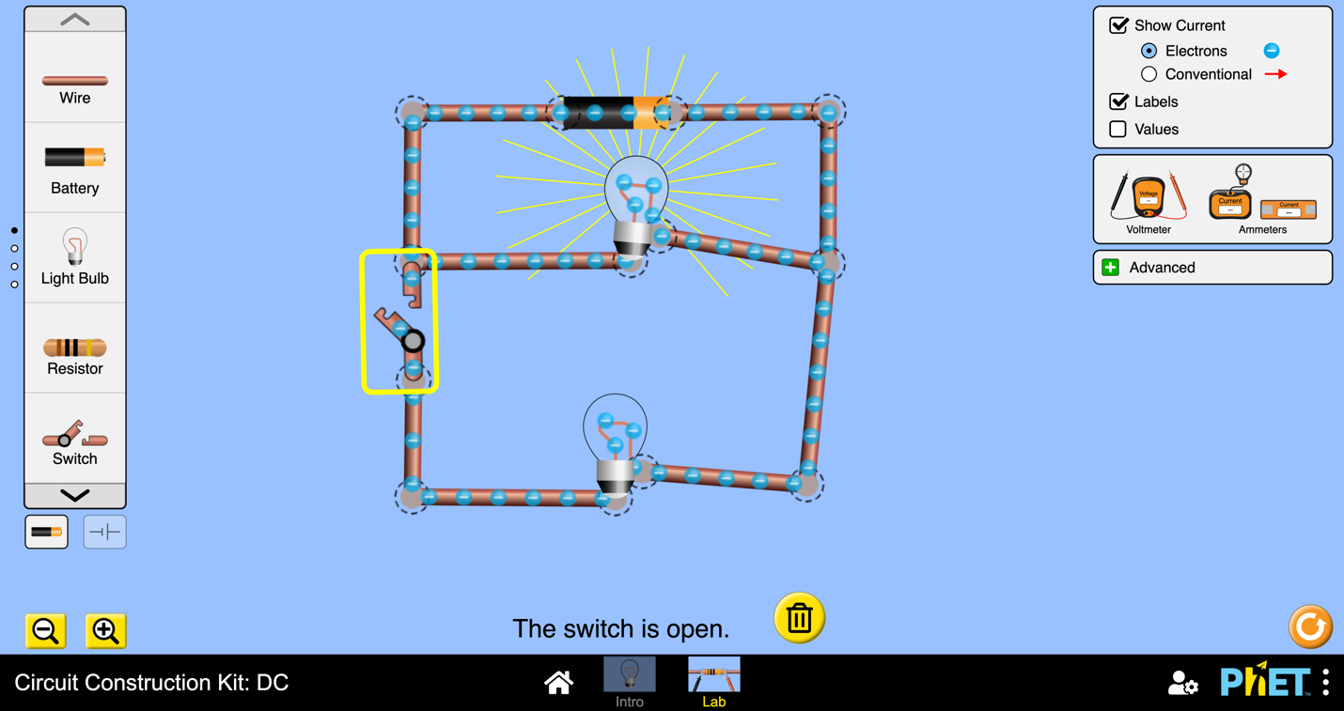

***Bedroom***

***The switch is open that’s why the other light bulb isn’t working or it didn’t light up***

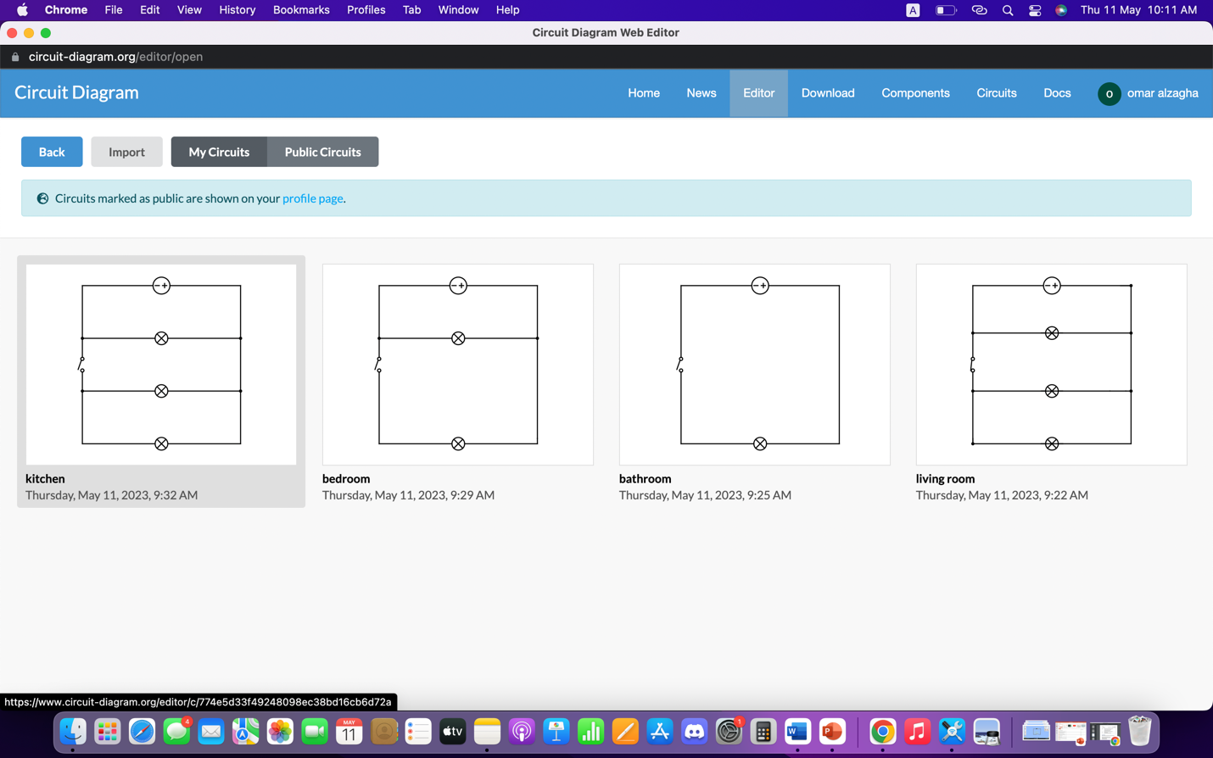

These are our sketches for the stimulations.