**Plants are Living Things**

Plants grow and develop, and they have DNA in their cells that they pass along to offspring when they reproduce. Plants respond to stimuli and maintain homeostasis**. All of these characteristics lead us to the conclusion that plants are living things.**

Tropic movements are important for plants because of the following reasons: *They serve as protective function. They help in developing a sudden response for a stimulus or change. It helps in the growth of pollen tubes towards the ovules.*

**Movement in plants**

Plants exhibit two types of movements.

1. Growth-dependent movements called the **Tropic Movements**. (towards or away from a stimulus)
2. Non-growth dependent movements called the **Nastic Movements**. ( independent of stimulus)

Tropic movements

These can be classified again into 5 types. They are:

* Phototropism (light)
* Geotropism (gravity)
* Hydrotropism (water )
* Chemotropism (chemicals)
* Thigmotropism (touch)

1. *Phototropism****–***It is the movement of plants in response to light. The shoot system of a plant exhibits this characteristic. The shoot moves towards the light.
2. *Geotropism****–***It is the movement of a plant part towards the [soil](https://www.toppr.com/guides/science/soil/soil-erosion/). This is a characteristic of the root system. The [roots](https://www.toppr.com/guides/biology/morphology-of-flowering-plants/root/) always move in the [direction](https://www.toppr.com/guides/business-management-and-entrepreneurship/direction-and-coordination/elements-of-direction-motivation/) of the earth’s gravity.
3. *Hydrotropism*– It is the movement of a plant towards the water. The stimulus here is water.
4. *Chemotropism*– It is the movement of plants in response to a chemical stimulus. A classic example of this type of movement is the [growth](https://www.toppr.com/guides/biology/plant-growth-and-development/growth-and-its-phases/) of the pollen tube towards the ovule, during [fertilization](https://www.toppr.com/guides/biology/sexual-reproduction-in-flowering-plants/fertilization-post-fertilization-events/" \t "_blank), in a flower.
5. *Thigmotropism*– It is a directional movement in plants in response to touch. For e.g. the plant tendrils climb around any support which they touch.

### Nastic Movements

Nastic movements in plants are not directional movements. They are not dependent on stimulus and are growth independent. For example, the leaves of a touch me not plant (Mimosa pudica), fold up immediately when touched. These kinds of changes occur due to the changes in the amount of water in the leaves. Depending on the quantity, they either swell up or shrink.

**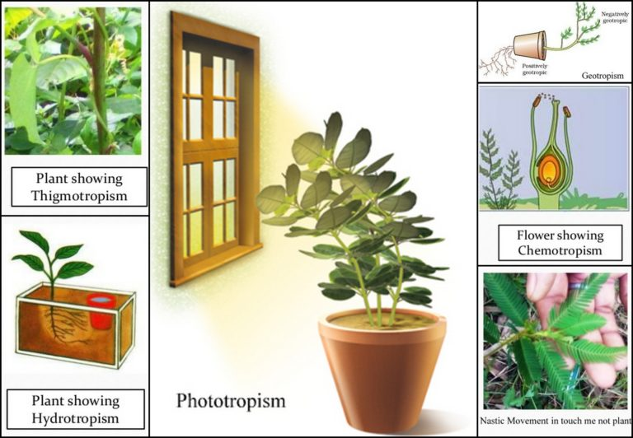**

**Example of movement in plants:**

A sunflower turns its face towards the sun due to phototropism.

**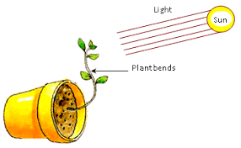**

**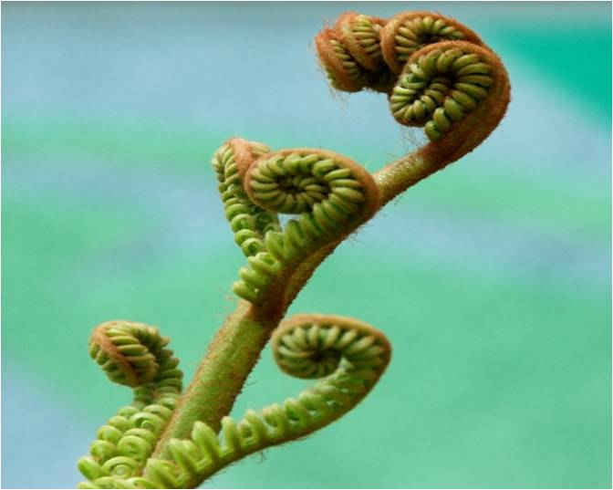**

**References**

1. [*"Carnivorous Plant Snaps Shut With 600 Gs"*](https://www.nbcnews.com/id/wbna41611513)*. NBC News. Retrieved 2022-07-06.*
2. ^ [Jump up to:***a***](https://en.wikipedia.org/wiki/Rapid_plant_movement#cite_ref-mulberry_3-0) [***b***](https://en.wikipedia.org/wiki/Rapid_plant_movement#cite_ref-mulberry_3-1) Taylor, P.E., G. Card, J. House, M. H. Dickinson & R.C. Flagan 2006. High-speed pollen release in the white mulberry tree, *Morus alba* L.. *Sexual Plant Reproduction* **19**(1): 19–24. [doi](https://en.wikipedia.org/wiki/Doi_(identifier)):[10.1007/s00497-005-0018-9](https://doi.org/10.1007%2Fs00497-005-0018-9)
3. [**^**](https://en.wikipedia.org/wiki/Rapid_plant_movement#cite_ref-4) *Poppinga, Simon; Weisskopf, Carmen; Westermeier, Anna Sophia; Masselter, Tom; Speck, Thomas (2016-01-01).*[*"Fastest predators in the plant kingdom: functional morphology and biomechanics of suction traps found in the largest genus of carnivorous plants"*](https://www.ncbi.nlm.nih.gov/pmc/articles/PMC4717191)*. AoB Plants.****8****: plv140.*[*doi*](https://en.wikipedia.org/wiki/Doi_(identifier))*:*[*10.1093/aobpla/plv140*](https://doi.org/10.1093%2Faobpla%2Fplv140)*.*[*PMC*](https://en.wikipedia.org/wiki/PMC_(identifier))[*4717191*](https://www.ncbi.nlm.nih.gov/pmc/articles/PMC4717191)*.*[*PMID*](https://en.wikipedia.org/wiki/PMID_(identifier))[*26602984*](https://pubmed.ncbi.nlm.nih.gov/26602984)*.*
4. [**^**](https://en.wikipedia.org/wiki/Rapid_plant_movement#cite_ref-5) *Martone, Patrick T.; Boller, Michael; Burgert, Ingo; Dumais, Jacques; Edwards, Joan; Mach, Katharine; Rowe, Nick; Rueggeberg, Markus; Seidel, Robin (2010-11-01).*[*"Mechanics without Muscle: Biomechanical Inspiration from the Plant World"*](https://academic.oup.com/icb/article/50/5/888/644877/Mechanics-without-Muscle-Biomechanical-Inspiration)*. Integrative and Comparative Biology.****50****(5): 888–907.*[*doi*](https://en.wikipedia.org/wiki/Doi_(identifier))*:*[*10.1093/icb/icq122*](https://doi.org/10.1093%2Ficb%2Ficq122)*.*[*ISSN*](https://en.wikipedia.org/wiki/ISSN_(identifier))[*1540-7063*](https://www.worldcat.org/issn/1540-7063)*.*[*PMID*](https://en.wikipedia.org/wiki/PMID_(identifier))[*21558248*](https://pubmed.ncbi.nlm.nih.gov/21558248)*.*

**Thanks**

Naya Yared