**Topic: Physics, ICT, Math**

**Objective: To design an electrical circuit for a small house**

**Team:**

Student’s Names:

1. Ahmad

2. Laith

3. ………………………………………………

4. ………………………………………………

5. ………………………………………………

**Selected Title/ Theme:**

……………………………………………………………………………………………………

**Resources:**

List of the resources used, please copy and paste the URL of used resources here :

1. ………………………………………………………………………………………………

2. ………………………………………………………………………………………………

3. ………………………………………………………………………………………………

**Your Submission:**

Kitchen:

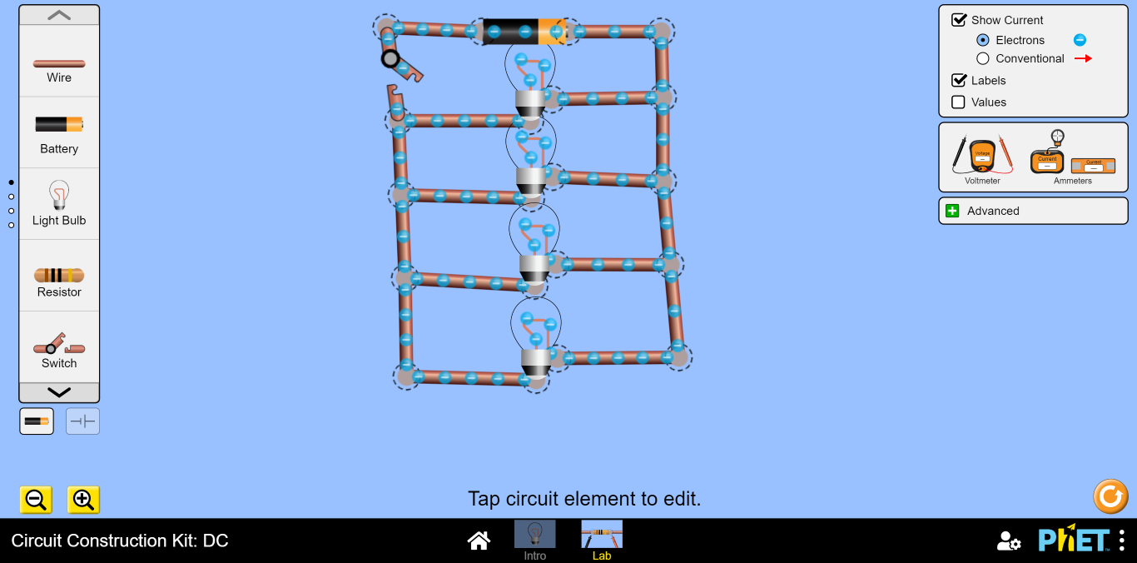

Bedroom:

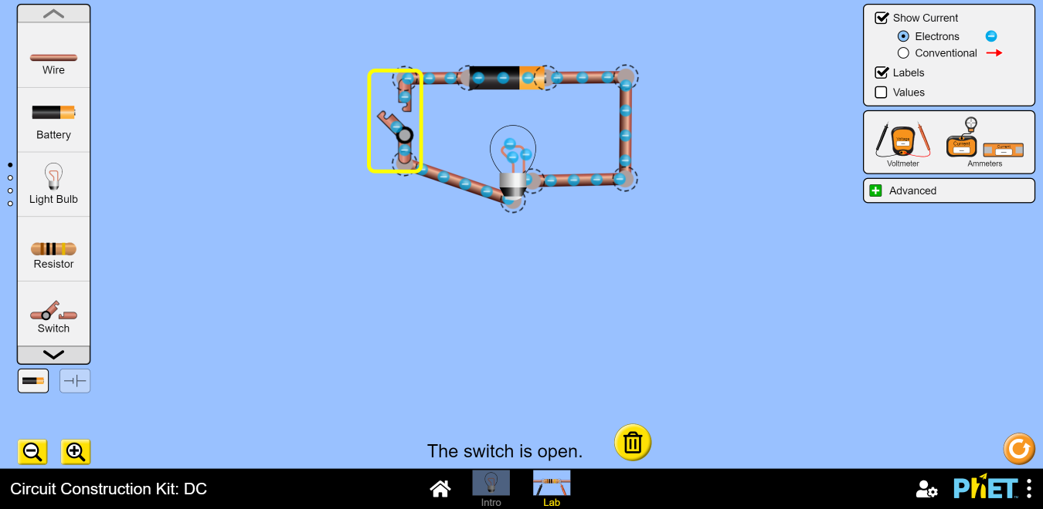

Living Room:

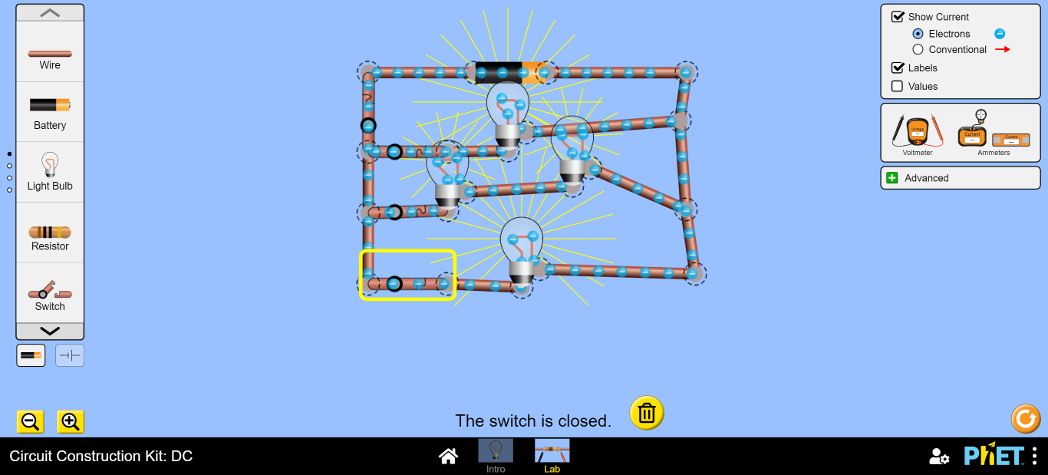

Bathroom:

