

Do plants really move?



Introduction

Plants do not have a nervous system, but they respond to various stimuli like light, temperature, touch, water, etc., which can be observed by their different movements called plant movements. As a result of external or internal stimuli, plants move their parts.

**Some types of moving plants are:**

* Tendrils
* Carnivorous plants
* Leguminosae
* Prayer plants
* Bladder wort
* Venus fly trap
* Trigger plants
* Star fruit (Averhoa carambola)

(But we will mainly focus on ……….sensitive plants)



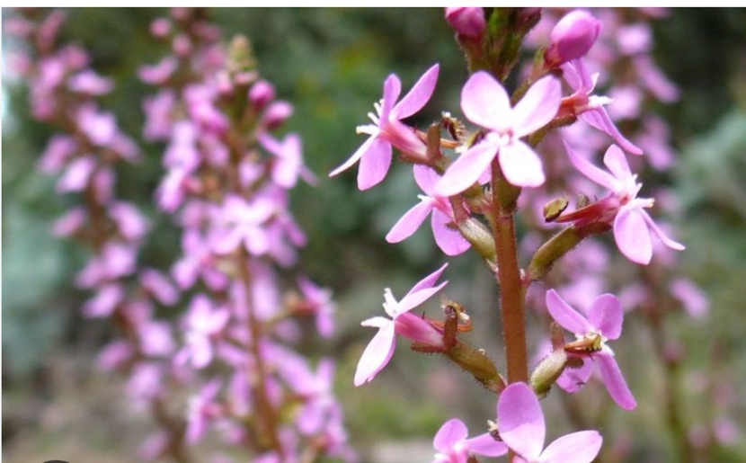

**What are trigger plants?**

The Trigger Plant gets its name from its unique pollination method. When an insect investigates a Trigger Plant flower, it is hit with a club-shaped column that quickly springs up from under the petals. The insect’s feeding activity disturbs small filaments in the center of the flower, activating the column. On the end of the column are male and female flower parts. The male parts deposit pollen on the insect, and the female parts can be fertilised by pollen on the insect if it has already been

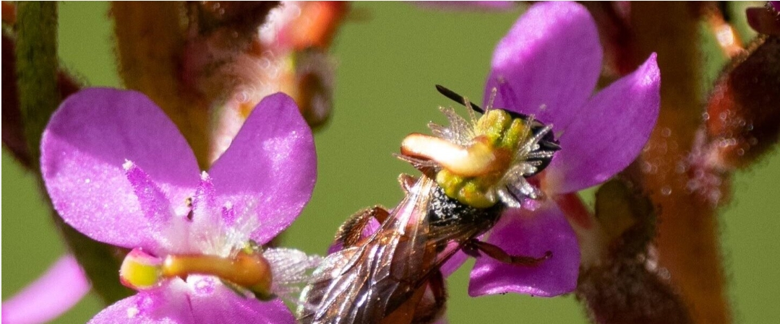

**What are sensitive plants?**

The Scientific Name is Mimosa pudica We can find the sensitive plant in Asia, Africa, North, South and Central America, A small prickly shrub, up to 50 cm tall and , They uses it as a source of pollen for honeybees, as a legume in soil improvement and in a wide-range of folk medicines for a large number of conditions, none of which according to CABI have been adopted for main-stream use. Sheep will graze on it.

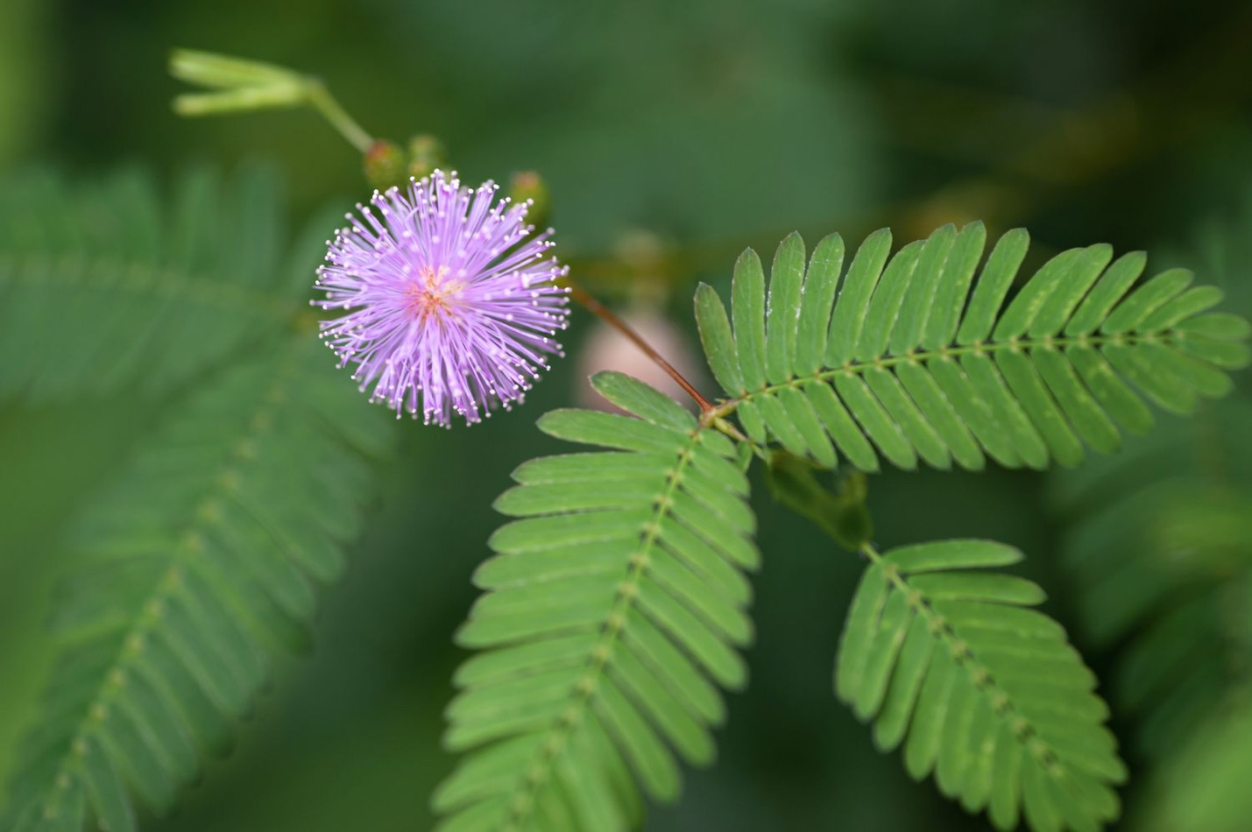

**Evidence that sensitive plants move:**

The sensitive plant's closing leaves are a good example of reversible leaf movement

The plant has very sensitive trigger hairs that, when triggered, snap its trap shut.

When the Mimosa pudica, commonly known as the sensitive plant, is touched by another organism, its leaves fold in upon themselves and its stems droop.

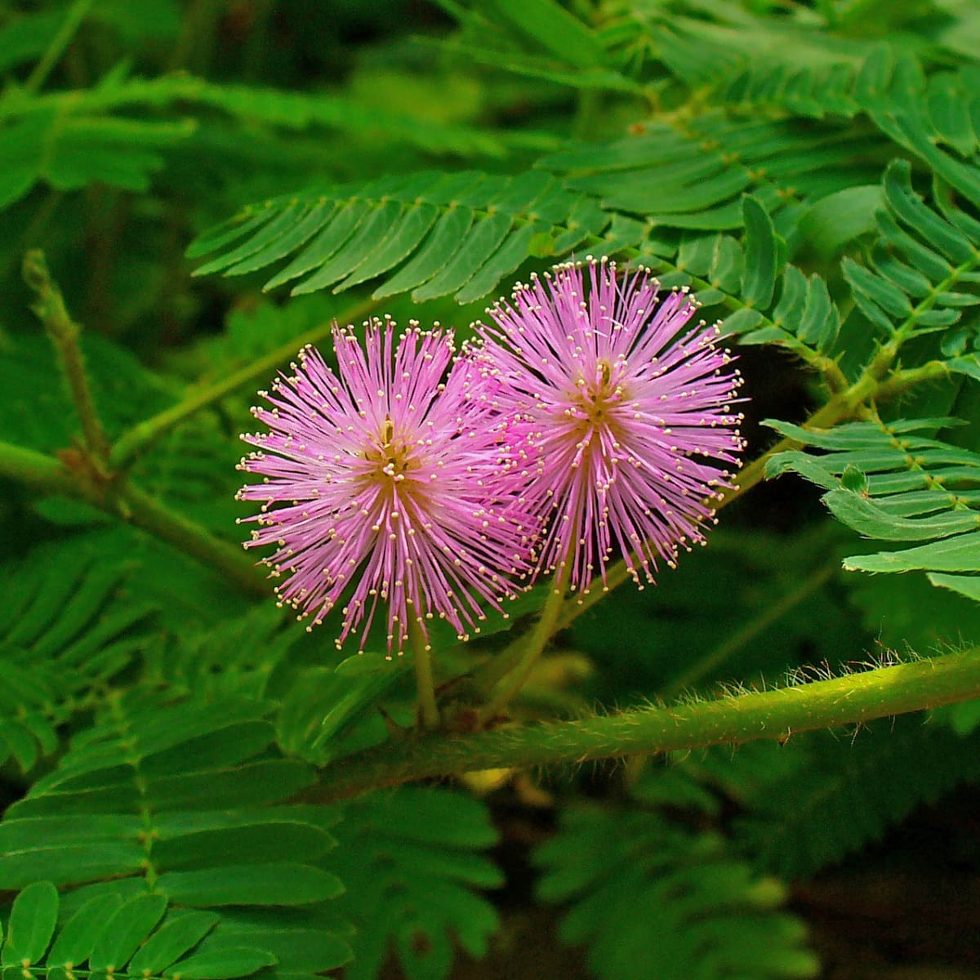

**Evidence that trigger plants move:**

The Trigger Plant gets its name from its unique pollination method. When an insect investigates a Trigger Plant flower, it is hit with a club-shaped column that quickly springs up from under the petals.

Trigger Plants are fascinating to watch. People can trigger the same explosive reaction as insects by tickling the inside of the flower with a bit of stiff grass. Once triggered, the column needs about an hour or more before it can hit again.

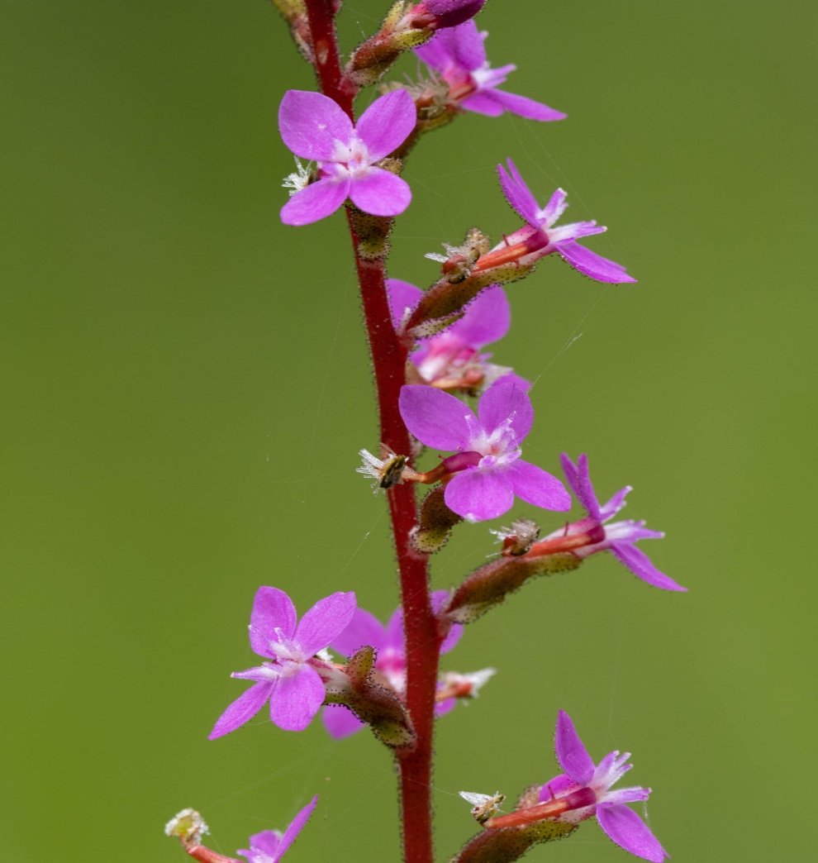

**Now, do plants really move?**

Plants do not move and are categorized as living things but they have similar characteristics to that of living organisms. Plants move is not just a response to light. Even if you knock over a plant, soon the leaves will have turned upward and the roots downward.

**THANK YOU FOR LISTING**

By:Miral,Salma,Selina,Natalie