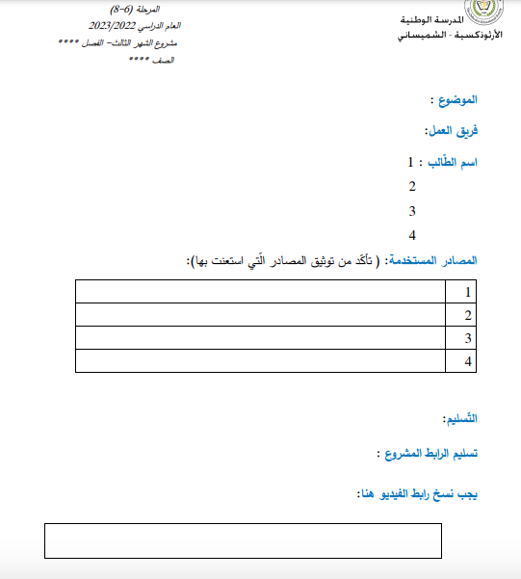

https://www.youtube.com/watch?v=to9RCWkTd8E

ميرال

https://mawdoo3.com/%D8%A3%D8%B3%D8%A8%D8%A7%D8%A8_%D8%A7%D9%84%D9%81%D9%82%D8%B1_%D9%88%D8%B9%D9%84%D8%A7%D8%AC%D9%87

https://manthoor.com/causes-of-poverty/

https://www.ohchr.org/ar/topic/poverty-right-food-and-social-protection

https://www.un.org/ar/global-issues/ending-poverty

* ميرال
* سلمى
* سيلينا عطلا
* نتالي

الفقر و الجوع