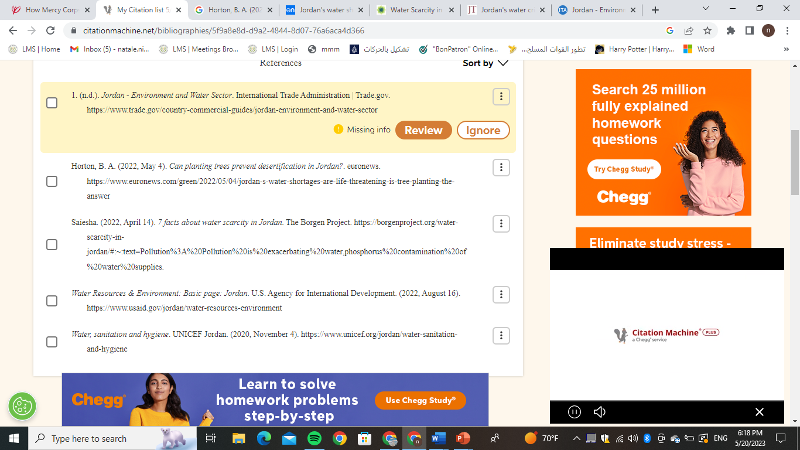

Note: All citations were produced by the citation machine linked in the resources