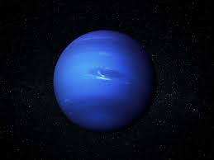

Neptune

Neptune is one of two ice giants in the outer solar system (the other is Uranus). Most (80% or more) of the planet's mass is made up of a hot dense fluid of "icy" materials – water, methane, and ammonia – above a small, rocky core. Of the giant planets, Neptune is the densest.

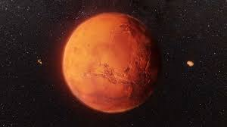

Mars is the fourth planet and the furthest terrestrial planet from the Sun. The reason Mars has a red color on its surface is due to the finely-grained iron(III) oxide dust in the soil, which give rise to its nickname, "the Red Planet

Mars