**Topic: House lighting design**

**Objective: 1-To design a circuit lighting diagram for a house.**

**2-To calculate the cost of components.**

**3-To calculate the monthly electricity bill.**

**Team:**

Student’s Names:

1.Basel Ebaid

2.Fahed Al-Deir

3.Sanad Mraybeh

4.Ghassan Bargouth

**Selected Title/ Theme:**

Light up your house!

**Resources:**

List of the resources used, please copy and paste the URL of used resources here :

1.<https://www.circuit-diagram.org/editor/>

2. <https://phet.colorado.edu/sims/html/circuit-construction-kit-dc/latest/circuit-construction-kit-dc_all.html>

**Your Submission:**

1. Submission document: uploaded to all subjects (*********) on LMS as a word file / PDF file by one team member only.

Living room simulation and circuit diagram:

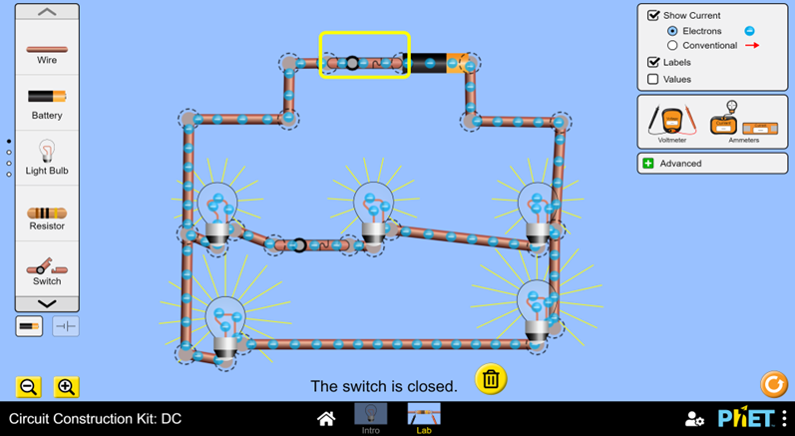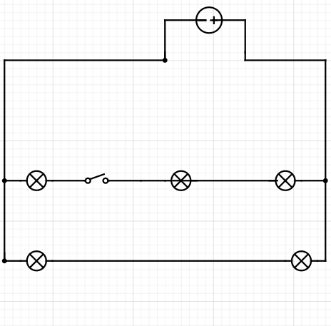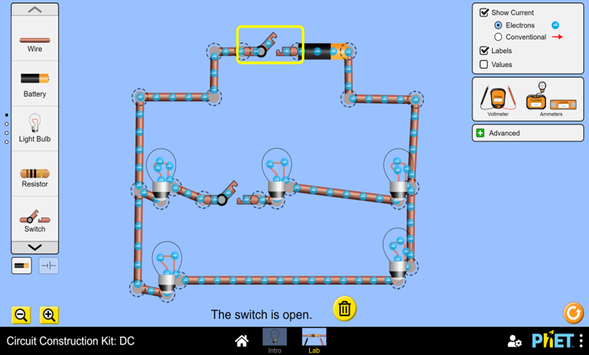

The battery and switch next to each other represent the DC source

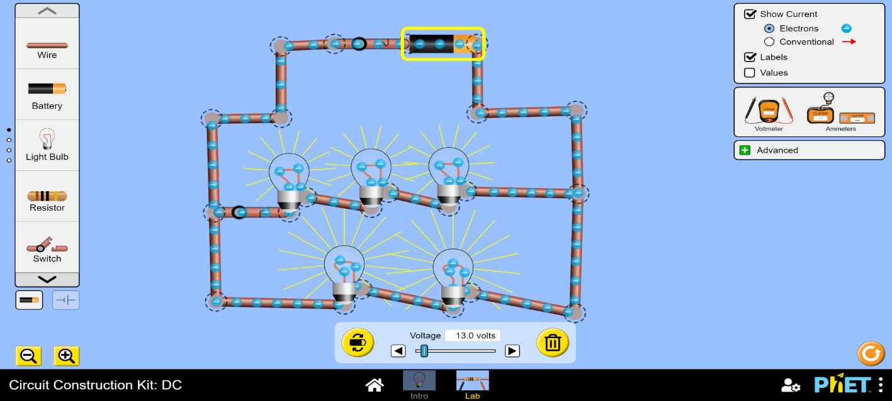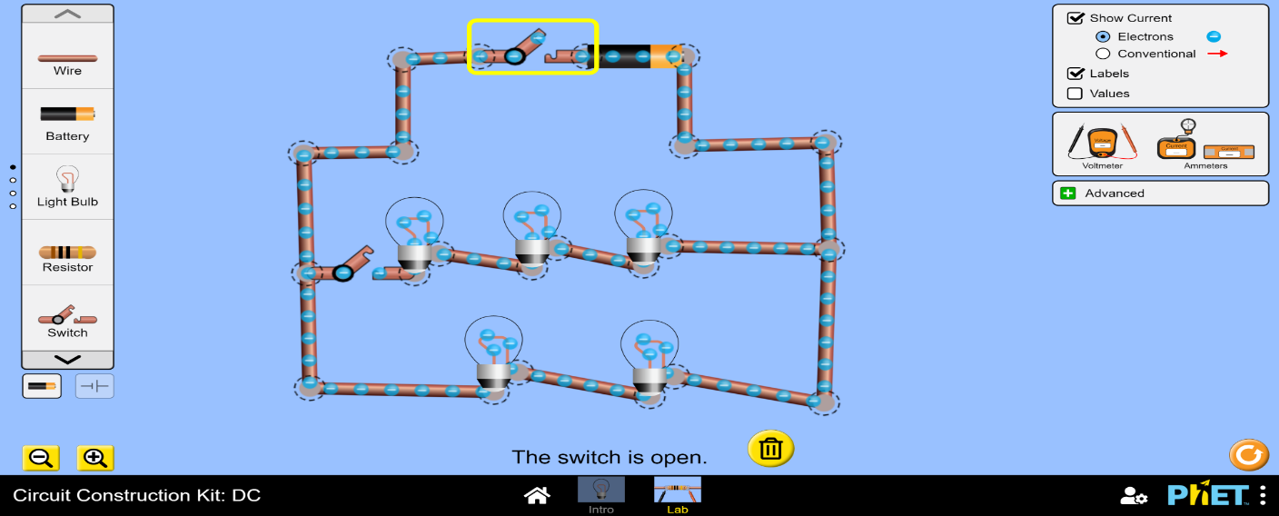Kitchen simulation and circuit diagram:

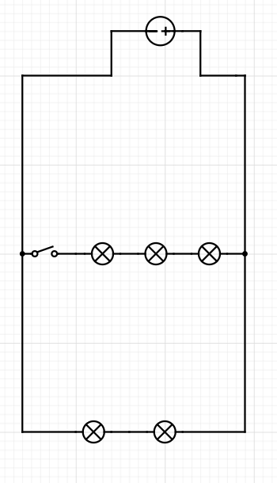

Bedroom simulation and circuit diagram:

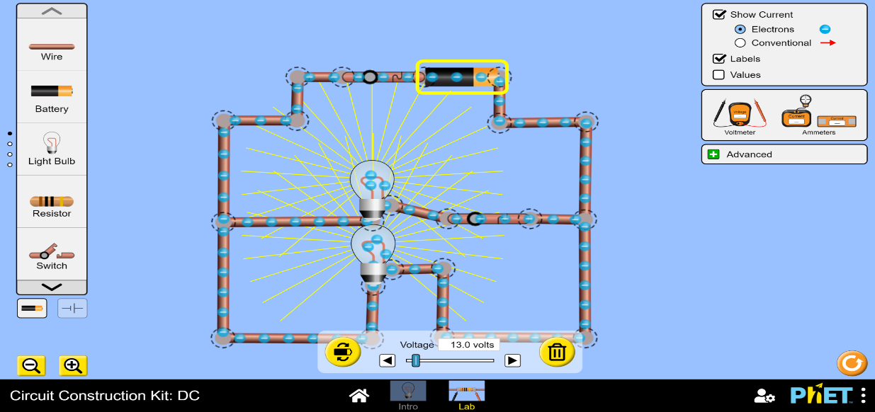

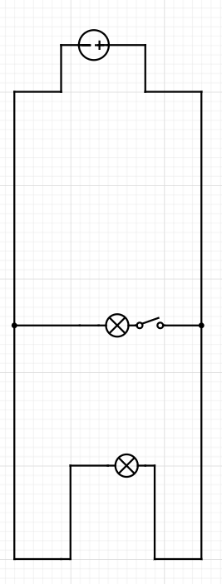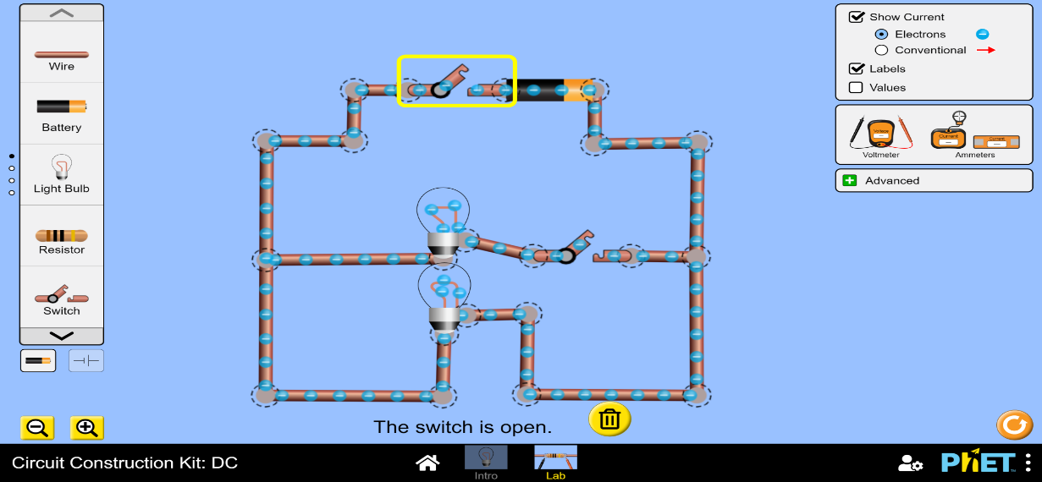

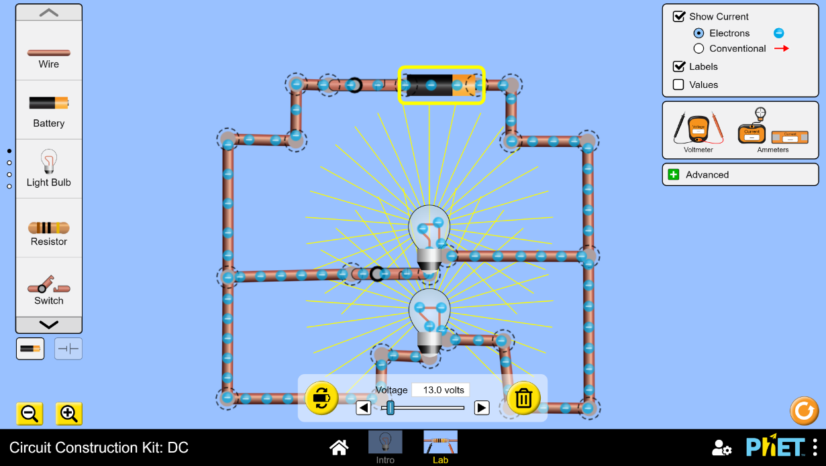Bathroom simulation and circuit diagram:

