By: Sama Kaawach, Dareen Al–Farah, , Lara Sawalha

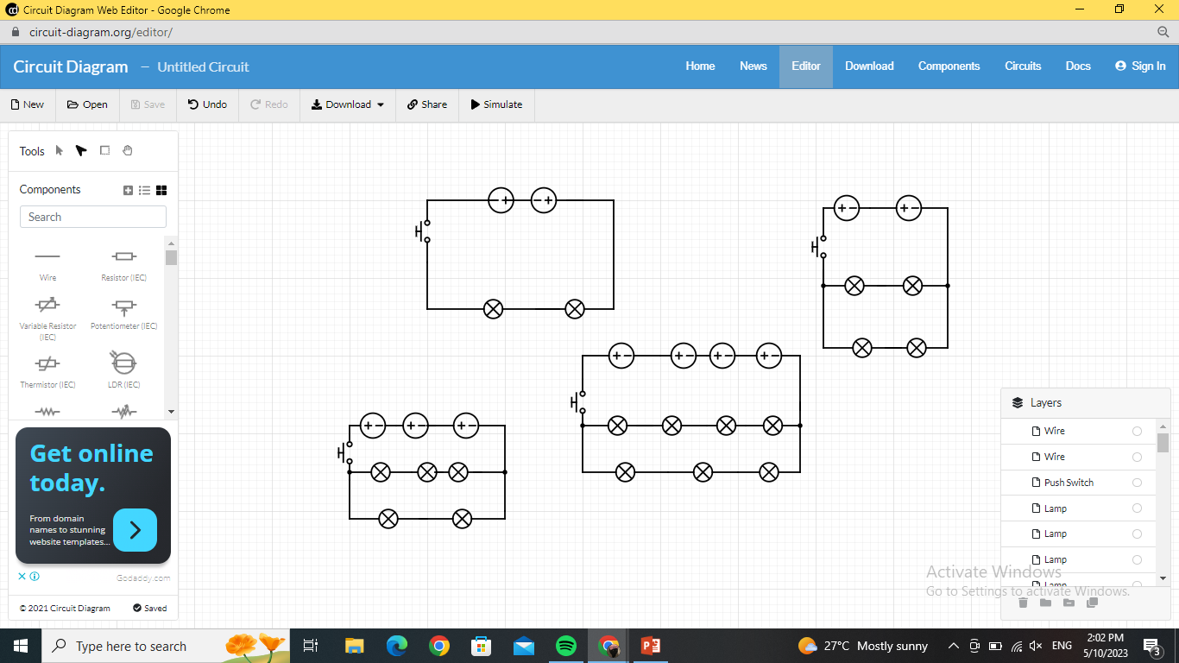**Bedroom**:

**Kitchen**:

**Living room:**



**Bathroom**: