So plants move too!

Done by: samia yaghnam, hind al shalabi, nadeen theodory

# How do we know that plants are a living thing? :

They are the only life forms that can produce their own food using energy from sunlight. Plants have green pigment called chlorophyll in their cells, mainly in the leaves. This pigment allows plants to make food from sunlight, water and carbon dioxide in a process called photosynthesis.

Types of movement in plants:

|  |  |
| --- | --- |
| Tropism | Phototropism |
| Tropism is a growth movement whose direction is determined by the direction from which the stimulus strikes the plant. | Provides the plant with a means to optimize photosynthetic light capture in the aerial portion and water and nutrient acquisition in the roots. |

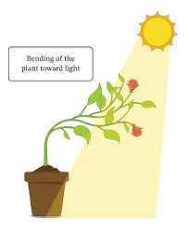 An external file that holds a picture, illustration, etc.
Object name is 10265_2020_1243_Fig1_HTML.jpg

Recources: <https://www.ncbi.nlm.nih.gov/pmc/articles/PMC7817606/>

<https://bio.libretexts.org/Bookshelves/Introductory_and_General_Biology/Book%3A_Biology_(Kimball)/16%3A_The_Anatomy_and_Physiology_of_Plants/16.02%3A_Plant_Physiology/16.2F%3A_Tropisms#:~:text=A%20tropism%20is%20a%20growth,growth%20away%20from%20the%20stimulus>.

<https://www.ncbi.nlm.nih.gov/pmc/articles/PMC5826749/>

Thank You