**Topic: light up your house**

**Objective**

**Team:**

Student’s Names:

1. …Muna ishnaneh……………………………………………

2. …Nabeel zureiqat……………………………………………

3. …Karam samara……………………………………………

4. …Martina jarjoura……………………………………………

**Selected Title/ Theme:**

Mario Lighting House

**Resources:**

List of the resources used, please copy and paste the URL of used resources here :

1. <https://www.circuitdiagram.org/>

2. <https://www.omnicalculator.com/everyday-life/lighting>

**Your Submission:**

1. Submission document: uploaded to all subjects (*********) on LMS as a word file / PDF file by one team member only.

Simulation Video:

<https://youtu.be/yaAp6D-ybiI>

Circuit Designs:

Living Room Circuit

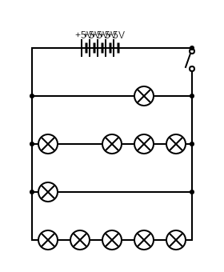

Kitchen Circuit:

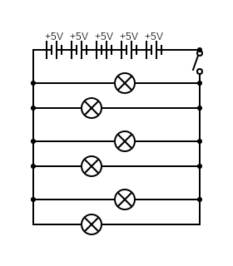

Bedroom Circuit:

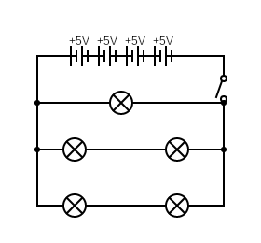

Bathroom Circuit:

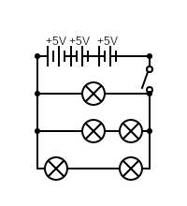

*Note: In the credits it is stated that Nabeel and Muna worked on the circuits, but Martina also worked on them