**Plants**

**Background information about plants:**

Plants are one of the two major groups of living organisms that are an essential entity to the function of the biosphere. Plants can be found in all known parts of the earth, in all shapes and sizes, although some plants are parasitic, most produce their own food through photosynthesis.



**Plants are also living things:**

Trees, bushes, a cactus, flowers and grass are examples of plants. Plants are living because they grow, take in nutrients and reproduce.

**Types** **of** **movements** **in** **plants:**

We can categorize plants into two types on the basis of their movements:

* Tropic movements
* Nastic movements

**Tropic movements:** Tropic movements involve the growth of plants. Examples – phototropism (response to light) – geotropism (response to gravitational pull) – chemotropism (response to chemicals) – thigmotropism (response to contact with objects) – thermotropism (response to temperature) – hydrotropism (response to water).

**Nastic movements:** In biology nastic movements are non-directional response to stimuli for example: (temperature, humidity, light irradiance)and are usually associated with plants. The movements can be due to changes in turgor **(internal pressure within plant cells).**

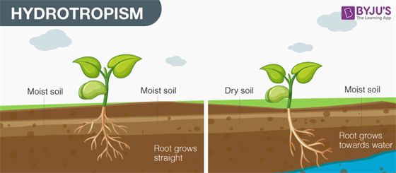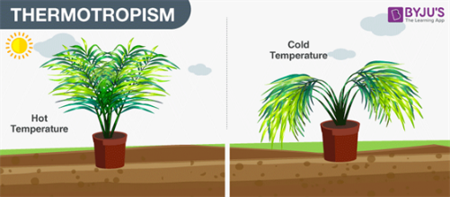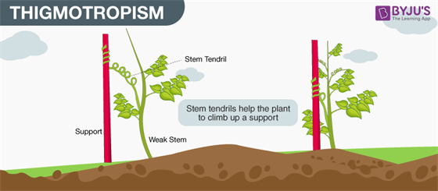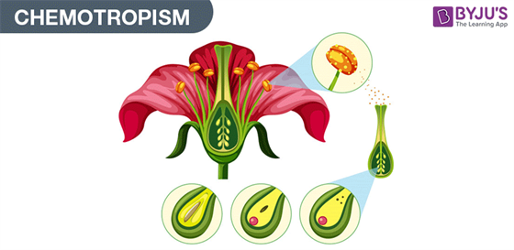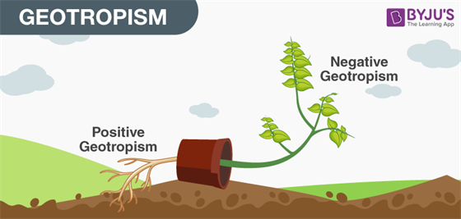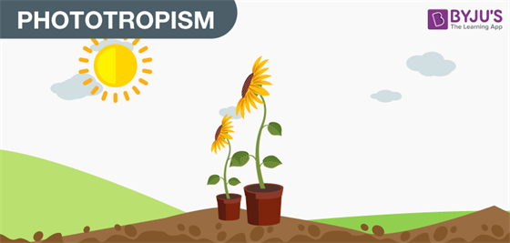**Types of tropic movements in plants**

**Examples of plants movement:**

* Sunflower turns its face towards the light (sun) due to phototropism
* The movement of the roots towards the water source

**FUN FACT-** Do you know that an average size tree can provide enough wood to make 170,100 pencils.

<https://www.youtube.com/watch?v=p3St51F4kE8>

References

1. https://www.ncbi.nlm.nih.gov/pmc/articles/PMC4844262/
2. <https://unacademy.com/content/neet-ug/study-material/biology/tropic-movements-in-plants/>
3. https://www.longacres.co.uk/blog/20-fun-facts-about-plants/

Group: Sama Al.soury – Nayefa Al-batarseh – Leith Mouasher – Faris Khoury – Saif Hijazeen