Um Nach 6 stehe ich auf

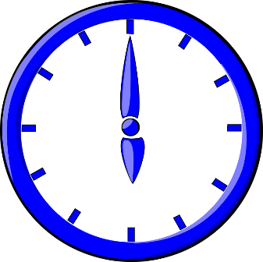

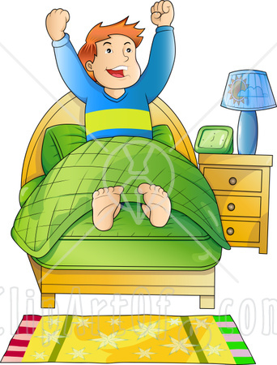

[This Photo](https://heartlandwriting.me/2010/07/20/nothing-here-to-be-afraid-of-its-just-the-mornin/) by Unknown Author is licensed under [CC BY-NC-ND](https://creativecommons.org/licenses/by-nc-nd/3.0/)

Um 7 uhr gehe ich in die Schule

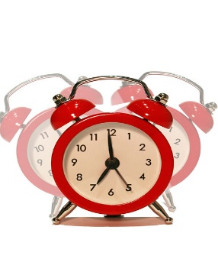

[This Photo](http://www.flickr.com/photos/alancleaver/4293345629/) by Unknown Author is licensed under [CC BY](https://creativecommons.org/licenses/by/3.0/)

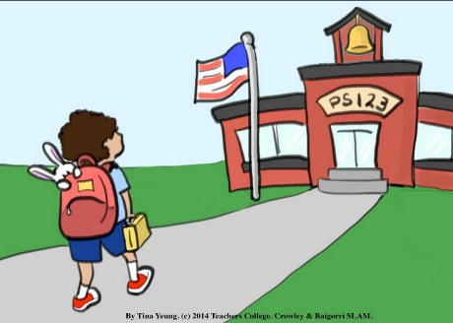

[This Photo](https://www.leadersproject.org/2015/03/17/slam-bunny-goes-to-school-cards-school-aged-language-assessment-measure/) by Unknown Author is licensed under [CC BY-NC-ND](https://creativecommons.org/licenses/by-nc-nd/3.0/)

Um halb elf frustucke ich

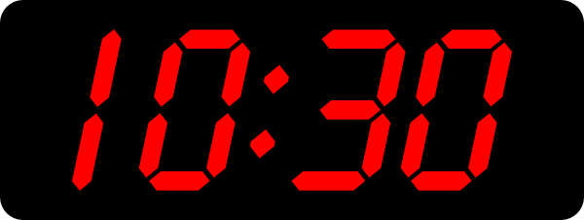

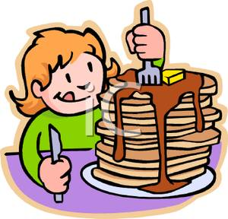

[This Photo](https://chaoticsoulzzz.wordpress.com/2012/03/06/five-reasons-to-be-single/) by Unknown Author is licensed under [CC BY](https://creativecommons.org/licenses/by/3.0/)

Um funf vor drei spiele ich badminton

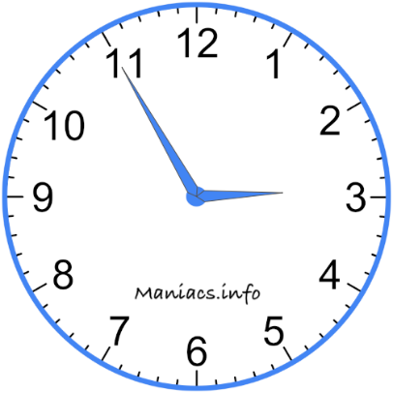

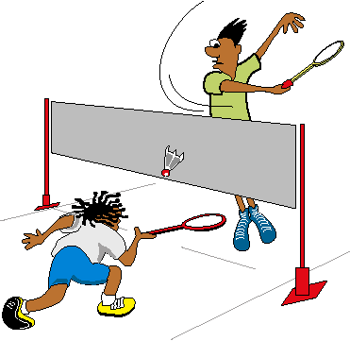

[This Photo](https://josjulior.blogspot.com/2011/03/el-badminton.html) by Unknown Author is licensed under [CC BY-SA-NC](https://creativecommons.org/licenses/by-nc-sa/3.0/)

Um halb sechs mache ich hausaufgabe und ich spiele video games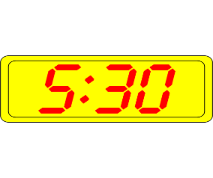

Um halb zehn gehe ich ins Bett

