***How Do Plants Move***

**How do plants move?**

Plants can’t travel from one place to another. Their roots anchor them in the ground, yet plants can respond to environmental changes bye the texture of the stem and leaf parts growing in specific directions.

**How do plants move (example)?**

A Sunflower turns it’s face towards the sun due to phototropism.

**What is Phototropism?**

Phototropism is the growth response of plant parts “Simulate of light”.

**What are the ways that plants move?**

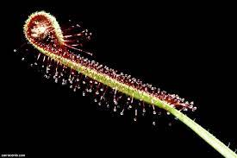There are multiple ways that plants move and some of them are; Phototropism, Geotropism, Hydrotropism, Thigmotropism, Chemotropism, and Thermotropism.

**Do all plants move?**

Although terresbail plants can’t move from one place to another some of their movement achieve many of the same functional ends as those of animals.

**Do plants move in a certain way?**

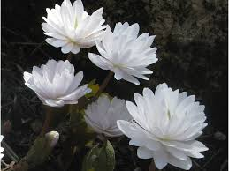They are capable of doing several types of movement. Like; tropism and that is the word used to describe plants movement towards or away from a stilumus.0

**Why do plants move?**

Plants need to move in order to grow, catch sunlight, and for some to feed.

**Examples of plants that move?**

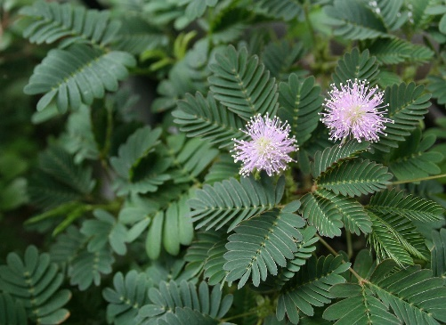There are many plants that move and some of them are; Sunflower, Aechynomene, Chamacrista, Starfruit, Mimosa, Biophytum, Nemtunia, Senna Alata.