Here are the circuits:

1-Living Room

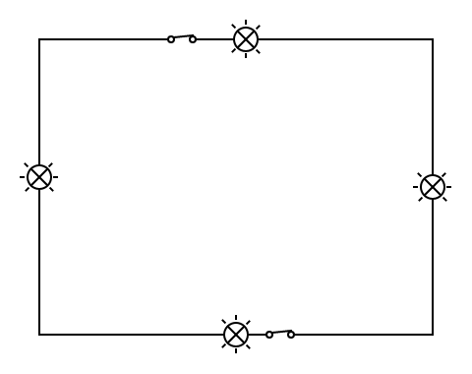

This model seems to be very suitable as lights are kept on the edges of the room to prevent annoying level of brightness, as this room is not very spacious.

2-Bedroom

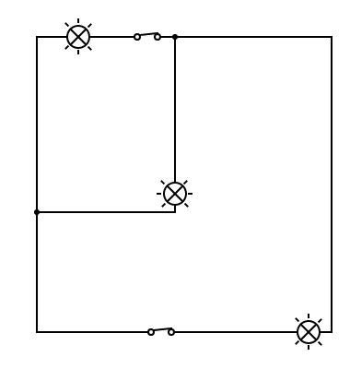

Three lights, one in the middle to reach parts of the room equally, with two switches for easier lamp access.

3-Kitchen

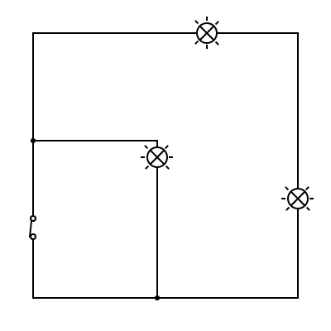

Similar to the bedroom design, this model contains three lamps, one of them in the middle right on top of the dinner table, with only one switch needed.

4-Bathroom

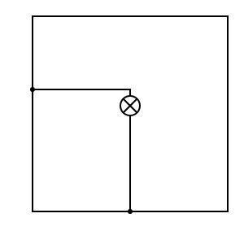

One motion activated light bulb, no switch needed.