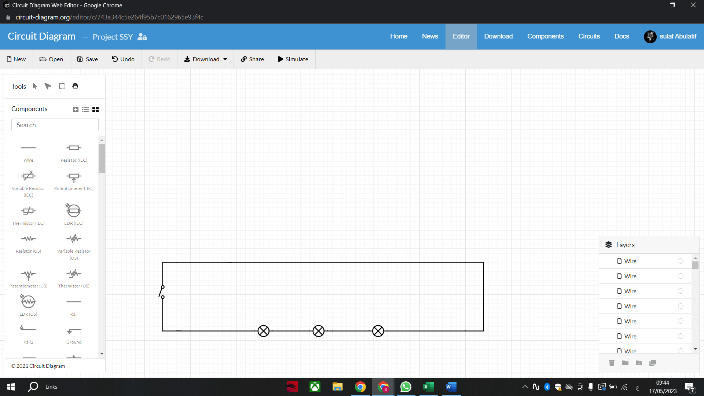Living room circuit:

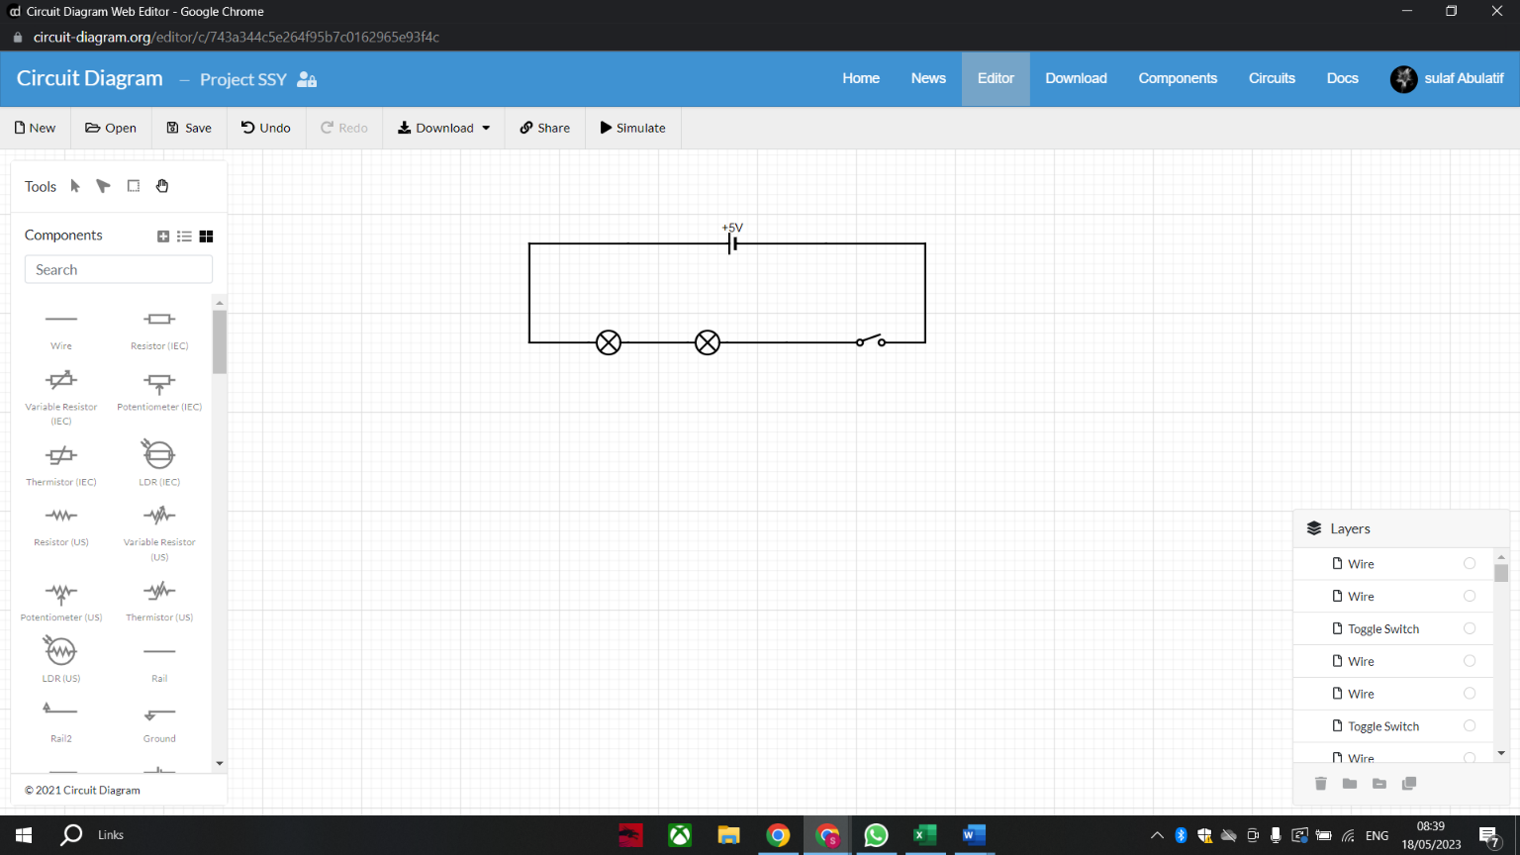Kitchen circuit:

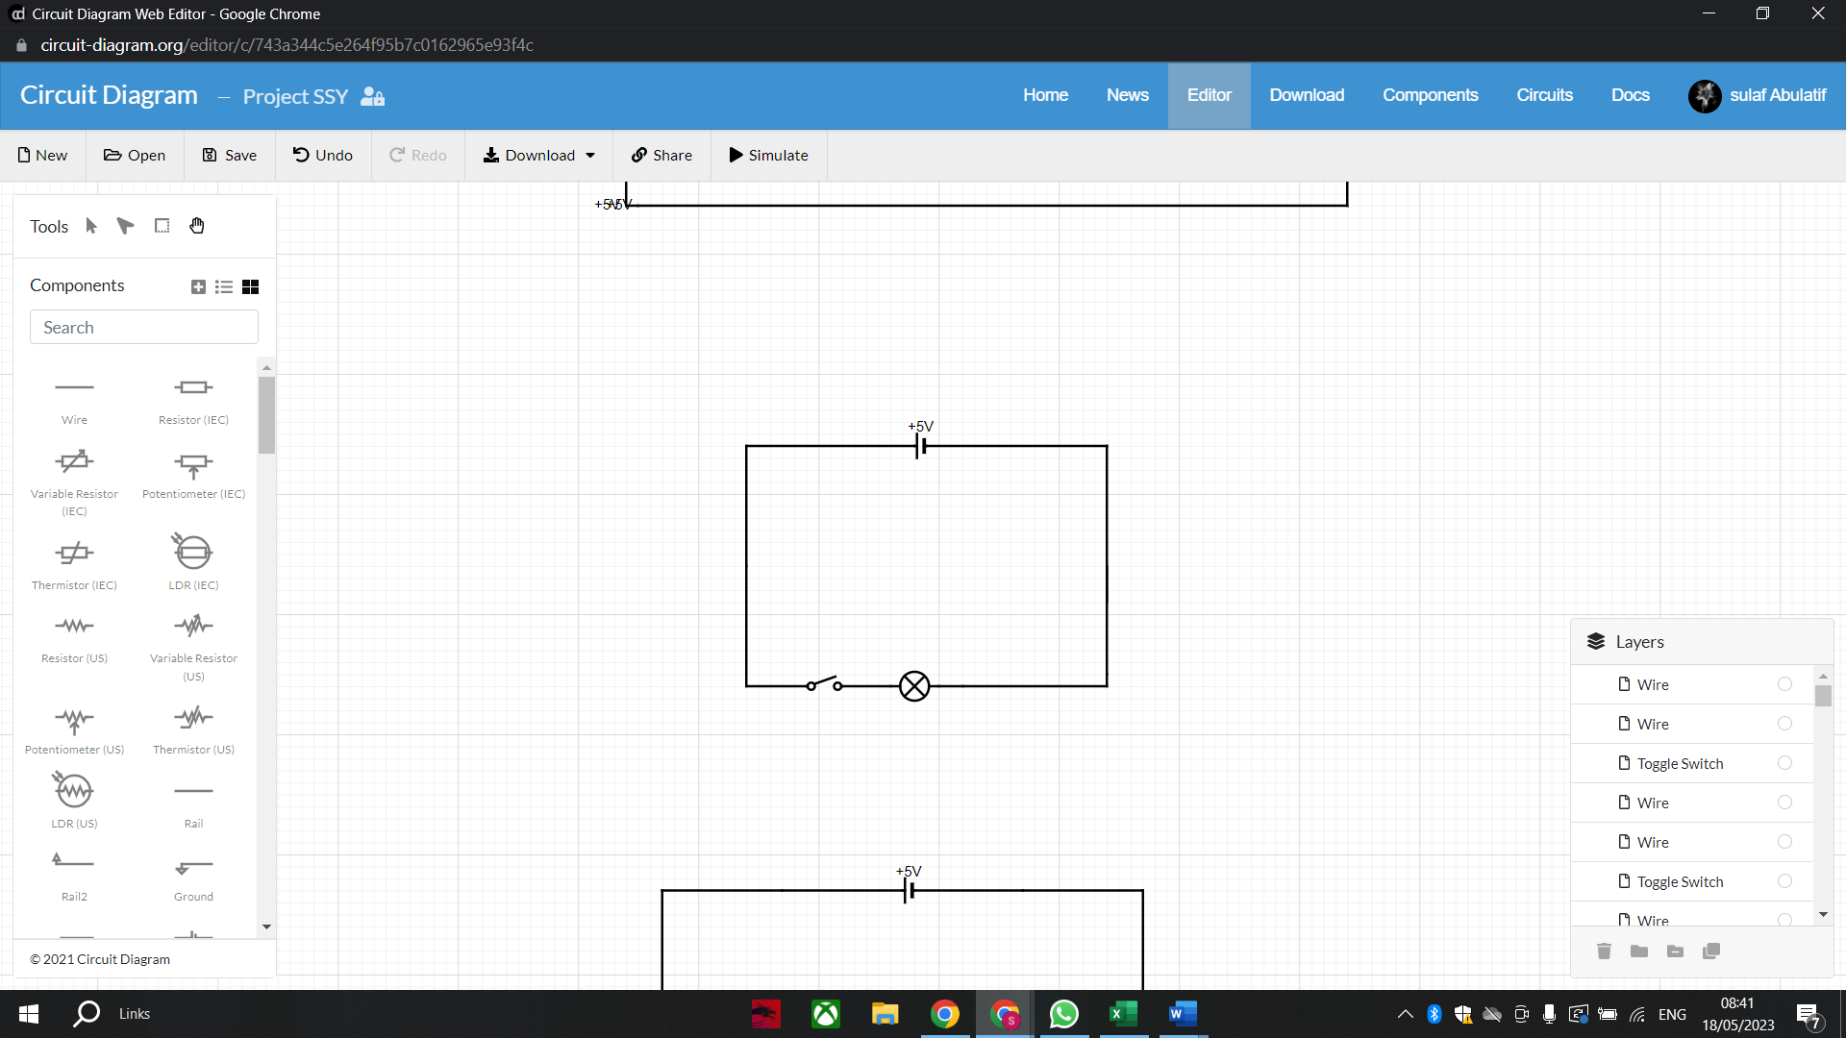

Bathroom circuit:

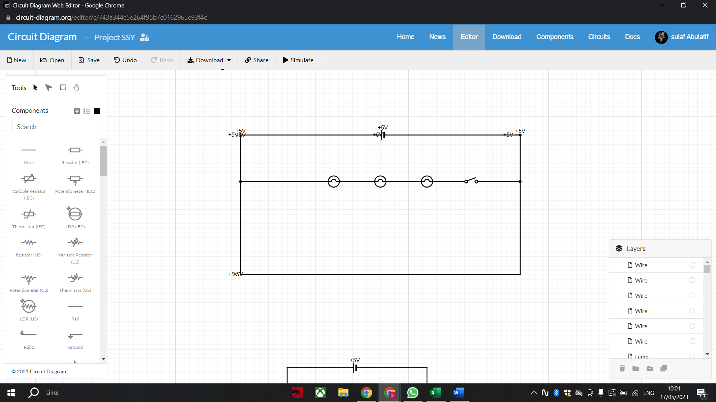Bedroom circuit:

Incandescent Light Bulb = CFL Light Bulb

Rail = LED Light wires

Generic Light Bulb = Normal Light Bulb

Ordinary Switch = Toggle Switch