

so plants can move!

Science & ICT Project



done BY: nadeen abu dayyeh / yasmeen alississ / angelina lallas

Grade: 7 (A)

**So plants can move too!**

**Plants are considered living things**

Plants are considered as living things because they fulfil all the characteristics of living things:

* Movement: with environmental changes and human interaction, trees do move. Plants move in groups the area of forests. New areas start to take expand while the original areas shrink.
* Respiration: plants breathe in carbon dioxide and breathe out oxygen.
* Sensitivity: plants react to their environment and the stimuli around them.
* Growth: Through photosynthesis and by absorbing nutrients, minerals and water through their roots, plants do grow
* Reproduction: Pollen and seeds make new plants
* Excretion: plants excrete waste (oxygen)
* Nutrition: obtaining food to build a body

(BYJUS, n.d.)

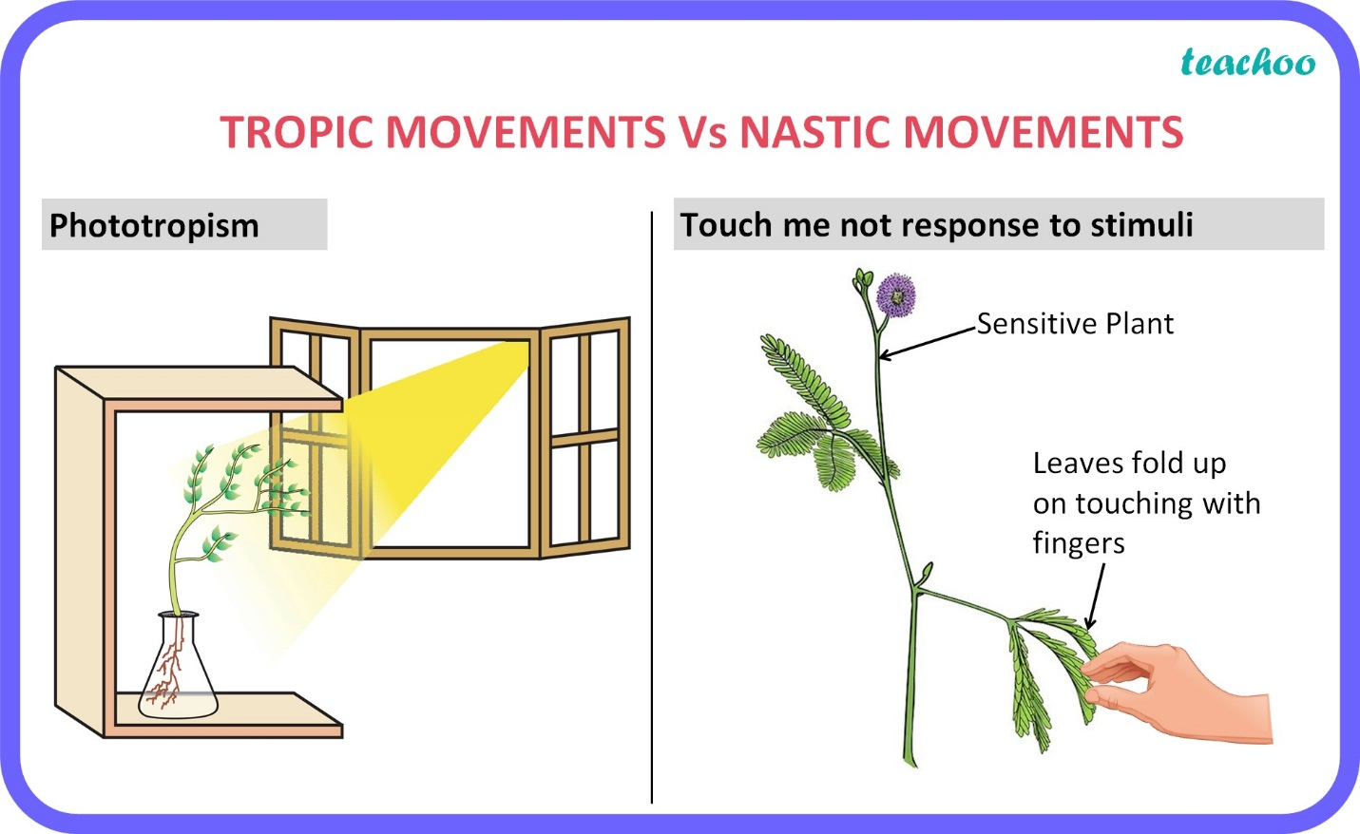

(TEACHOO, n.d.)

**Types of movements in plants**

Plant movements include movements toward light, opening and closing of flowers, growth of developing roots in search of water and nutrients, etc.

(Sisodia, 2023)

1. Tropic movement: The movement of a plant in the direction of stimulus is known as Tropic movement or tropism.

Types of tropism are as follows:

* Hydrotropism: Movement due to water.
* Phototropism: Movement due to light.
* Chemotropism: Movement due to chemical energy.
* Geotropism: Movement due to soil.

**Examples on plant movements**

1. Tropic movements:

* Hydrotropism: An example is the movement of roots towards the water source.

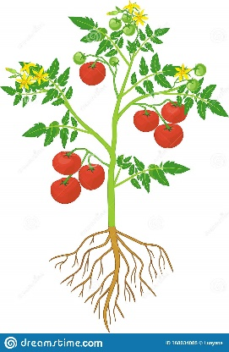

Tomato Roots

* Phototropism: An example is the Growth of aerial parts of plants towards light.

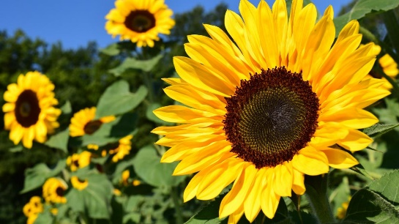

**Sunflower**

* Chemotropism: An Example is during the process of fertilization, the movement of the Pollen tube towards the Ovule due to the secretion of a sugary chemical in the ovary.

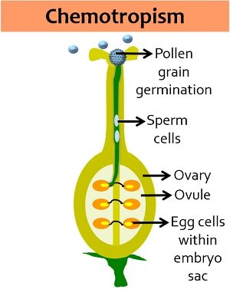

* Geotropism: An Example is the Growth of fruits of plants in a downward direction.

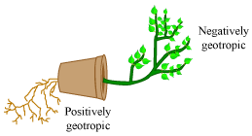

# References

*BYJUS*. (n.d.). Retrieved from https://byjus.com/question-answer/how-can-we-consider-plants-to-be-alive-give-examples-also/

*https://homework.study.com/explanation/is-a-plant-a-living-thing-justify-your-answer.html*. (n.d.). Retrieved from https://homework.study.com/explanation/is-a-plant-a-living-thing-justify-your-answer.html.

Sisodia, R. (2023). Plant Movements. *RESEARCHGATE*.

*TEACHOO*. (n.d.). Retrieved from https://www.teachoo.com/17568/3521/Question-2-Page-122/category/Questions-from-inside-the-book/

*VEDANTU*. (n.d.). Retrieved from https://www.vedantu.com/question-answer/describe-the-various-movements-of-plants-with-class-11-biology-cbse-5f7e9d4e0c5c184a898480a9: https://www.vedantu.com/question-answer/describe-the-various-movements-of-plants-with-class-11-biology-cbse-5f7e9d4e0c5c184a898480a9

*VEDANTU*. (n.d.). Retrieved from https://www.vedantu.com/question-answer/describe-the-various-movements-of-plants-with-class-11-biology-cbse-5f7e9d4e0c5c184a898480a9