Project

Science computer math

Made by Joelle Samaan,Michael Qsous and Fayez Aluzaizi

Living room

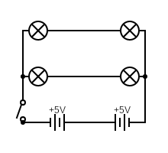

This is the living room it is half series half parallel circuit and has 4 LED bulbs in every corner and a switch and 5 sockets for different components

Kitchen

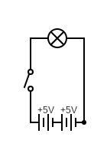

This is the kitchen it has a main LED bulb near the entry and has 5 sockets for different components and finally again a switch next to the entry

Bed room

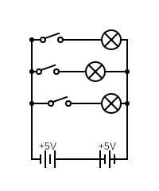

This is the bedroom it is the only one that is a full parallel circuit it also has one main LED bulb in the middle and 2 separate LED lamps on the sides it has 5 sockets for the lamps and other components and finally a main switch near the entry

Bathroom



this is the bathroom it has the same circuit diagram as the kitchen because it has only one main led lamp in the center of the room and has a socket near the entry and a switch next to it