These are the simulations and circuit diagrams of the living room, kitchen, bedroom & bathroom with explanations on each diagram.

Light up your house!

By: Hala, Tania &Carla

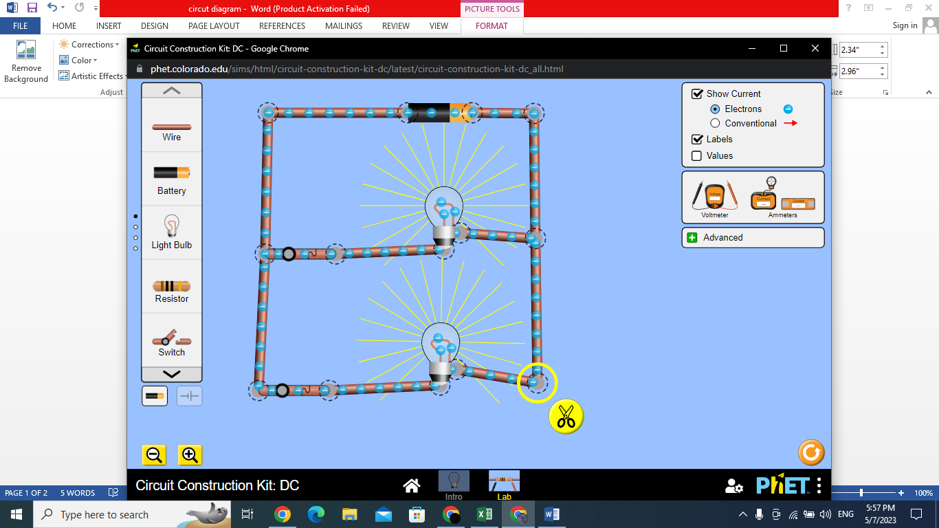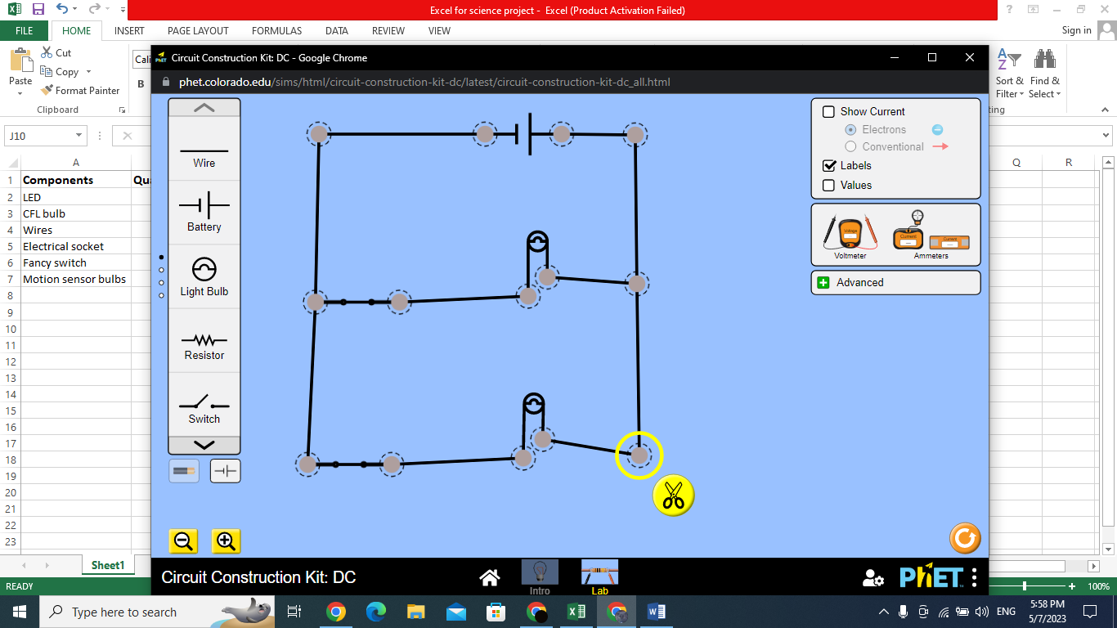

**Explanation:-**

**This is the lighting system for the living room, we will have 2 CFL bulbs lighting both sides of the room and we have 2 fancy switches to be able to turn each one on and off individually.**

**Living room**

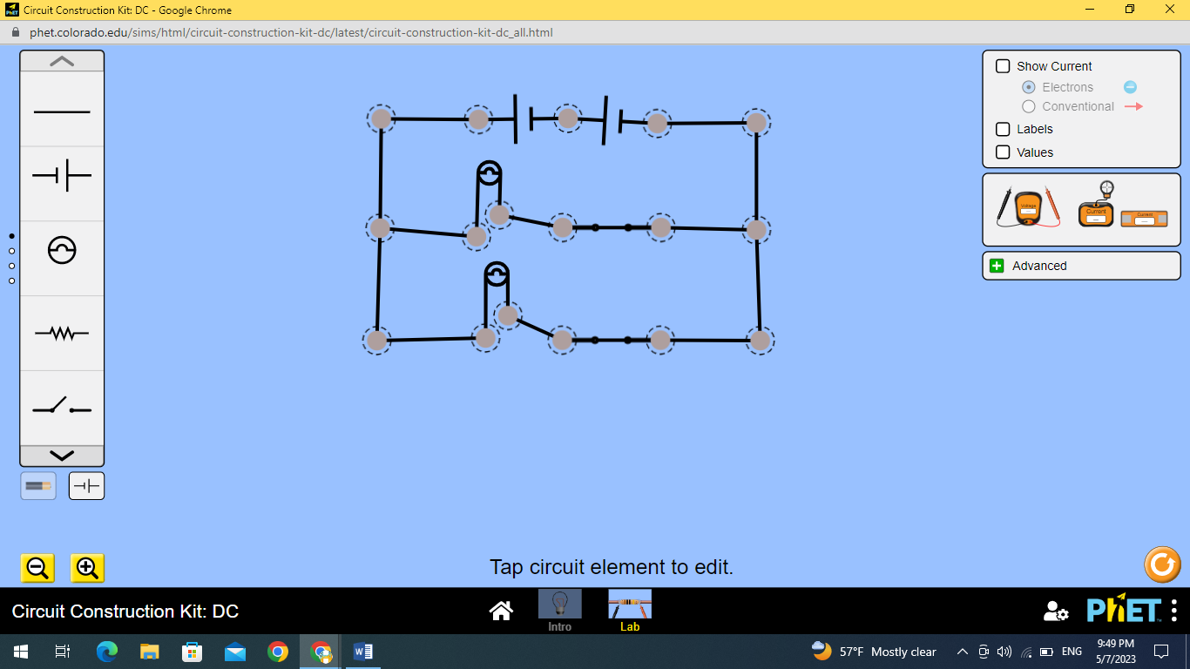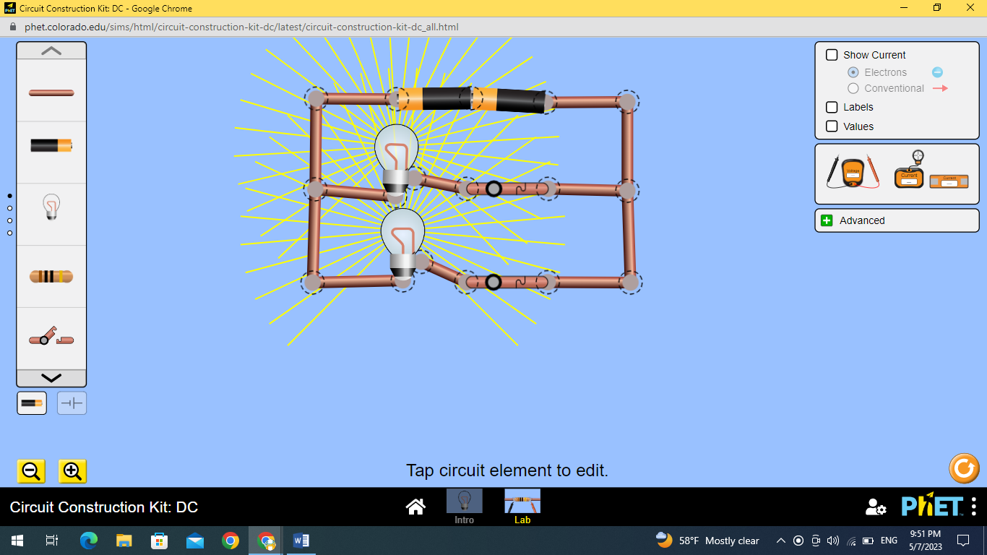

**Explanation:-**

**This is the lighting system for the kitchen, we have 2 CFL light bulbs on each side of the room which can be turned off and on individually by 2 fancy switches.**

**Kitchen**

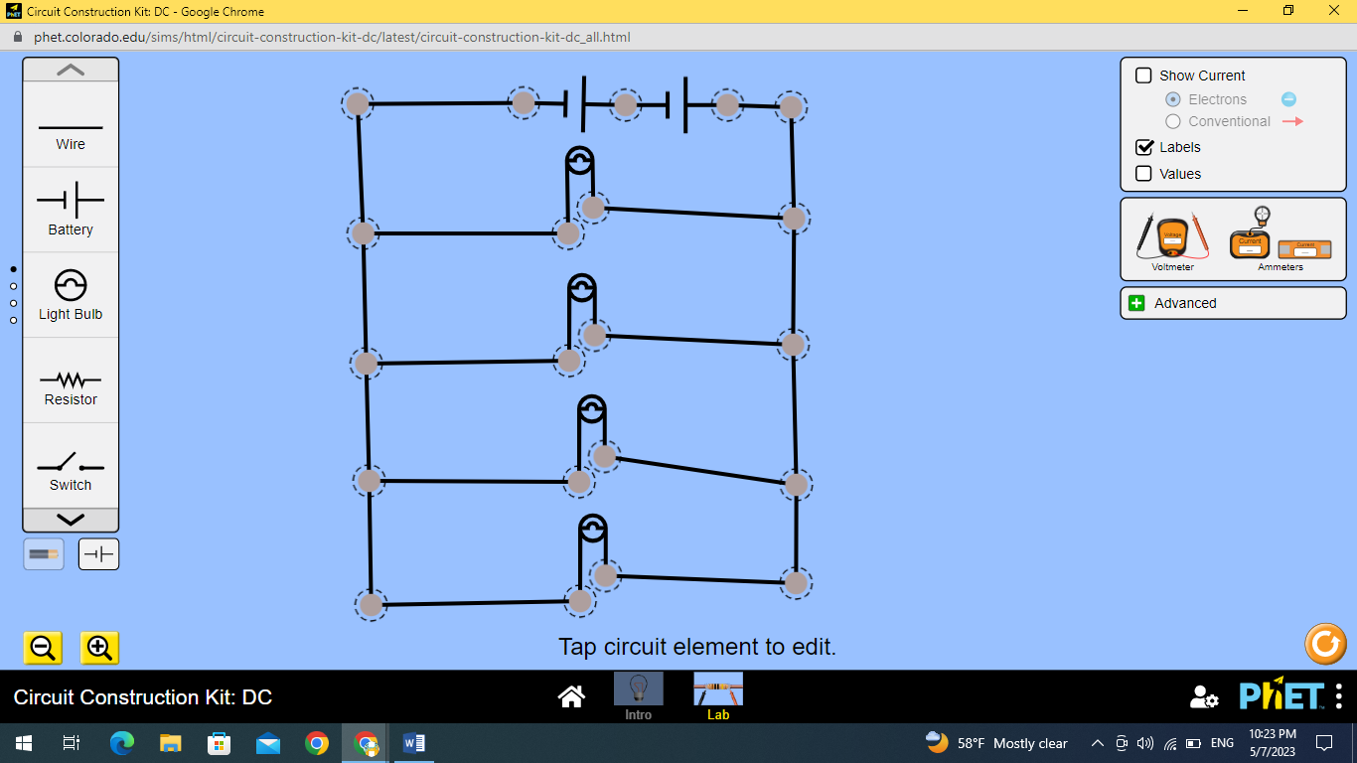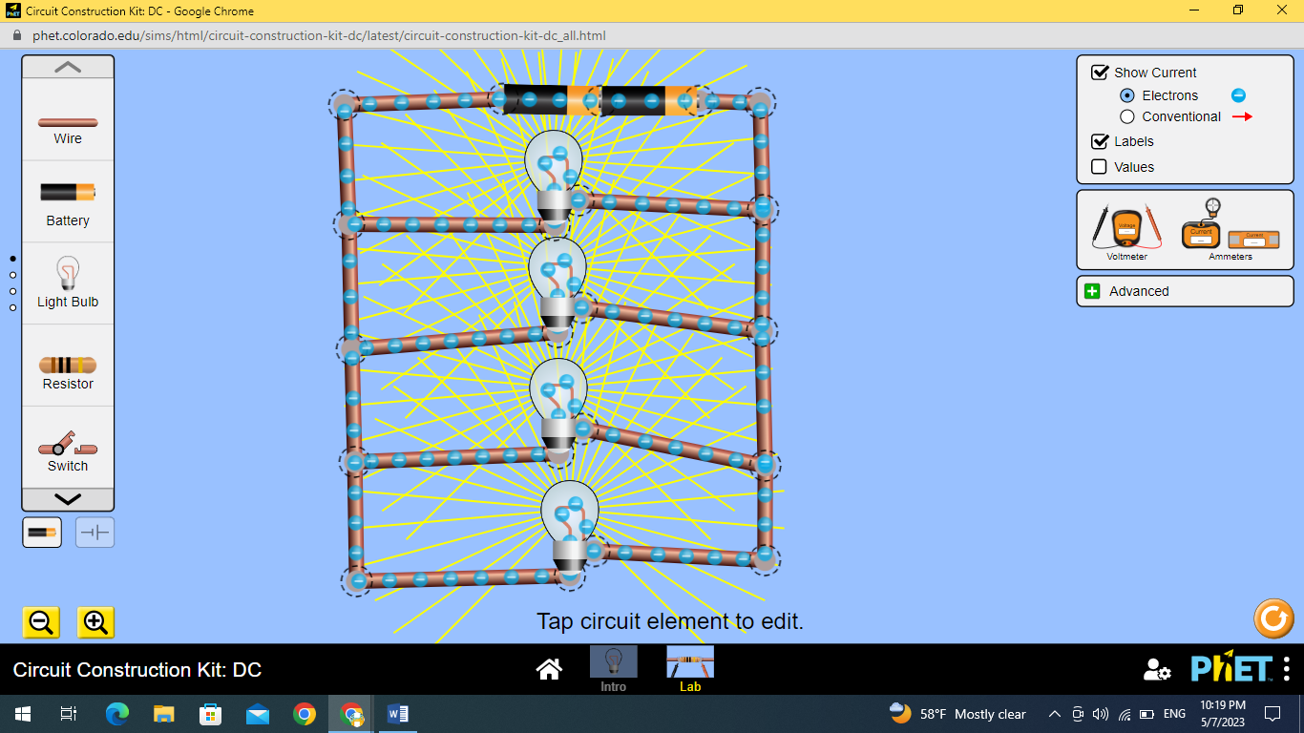

**Explanation:-**

**We have 4 motion sensor light bulbs that will be turned on when you open the kitchen cabinets.**

**Bathroom**

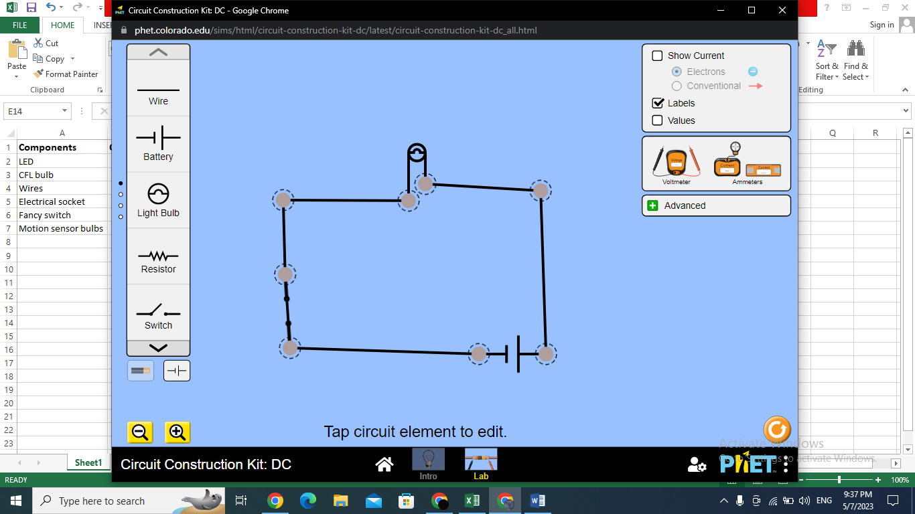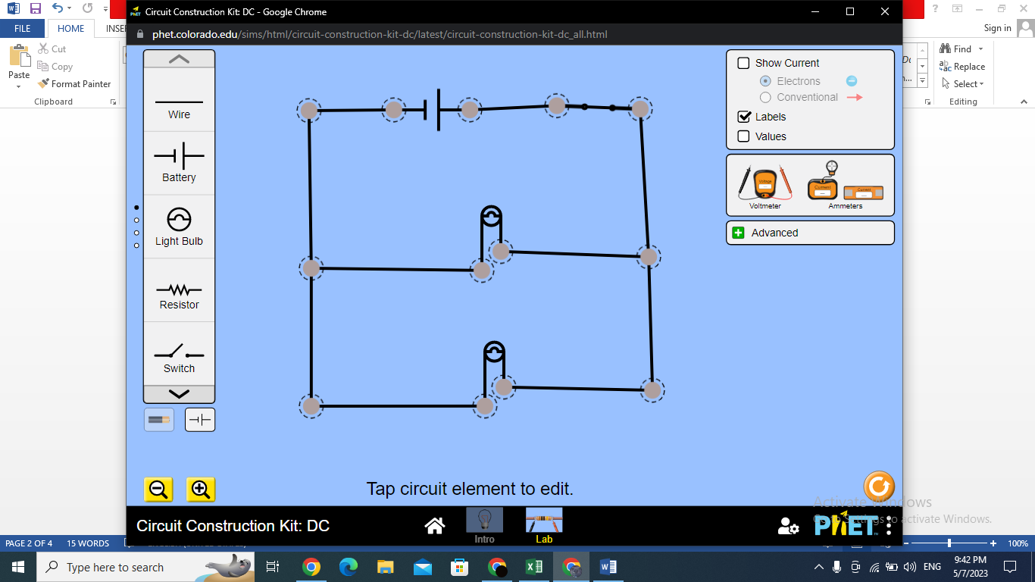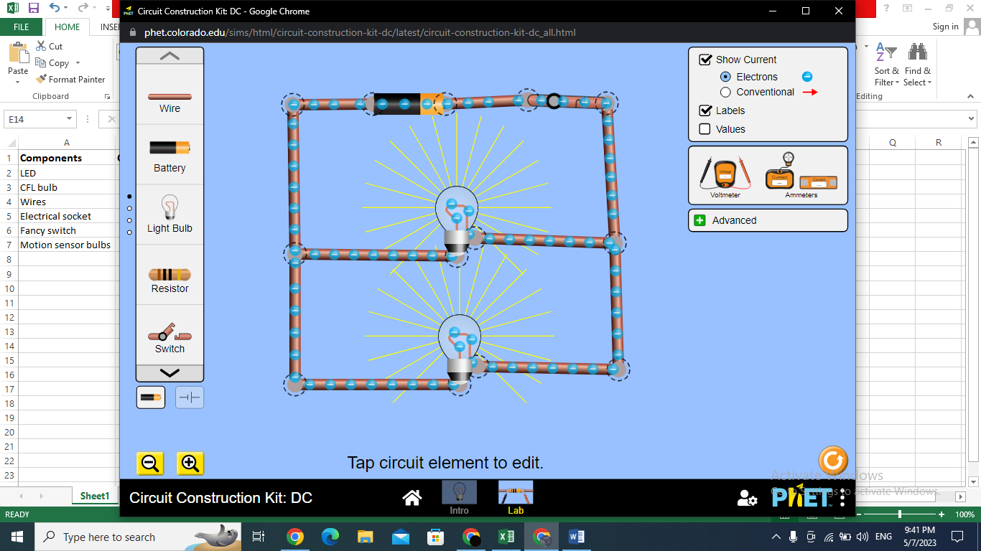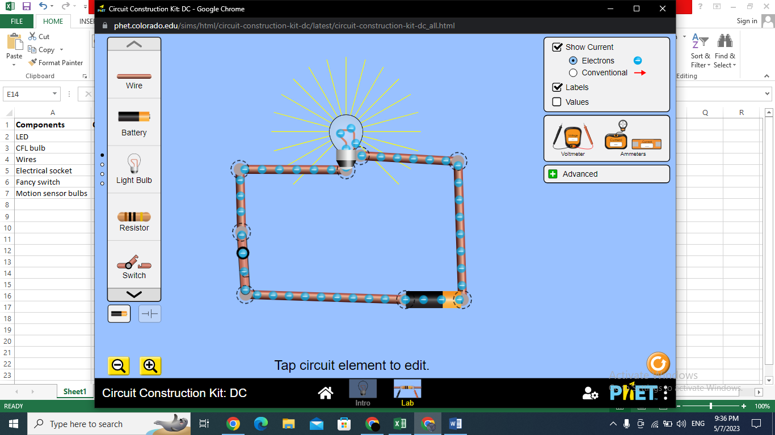

**Explanation:-**

**This is the lighting system for the bathroom, we have an LED light bulb in the center of the room which has a fancy switch to turn it on and off.**

**Explanation:-**

**There are 2 CFL light bulbs which are found above the bathroom mirror, which can also be controlled by a fancy switch.**

**Main Circuit**

**Main Circuit**

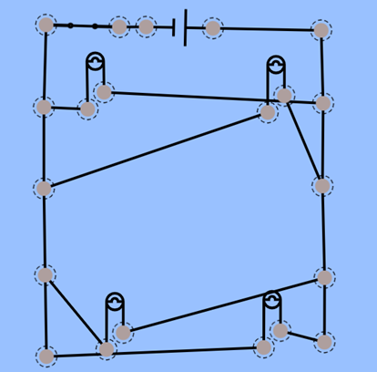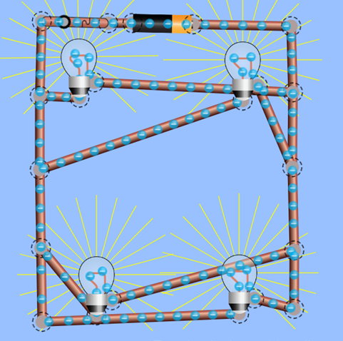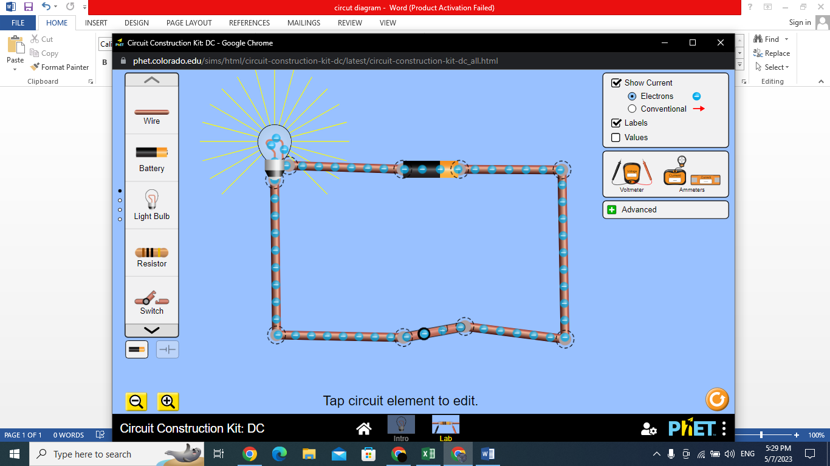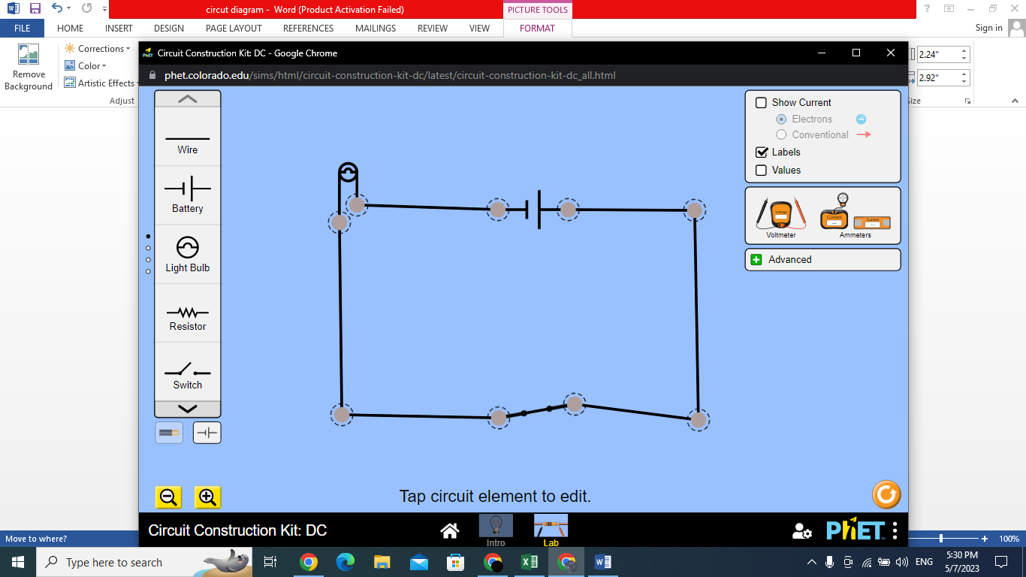

**Bedroom**

**Explanation:-**

**This is the lighting system for the bedroom. We placed 4 LED light bulbs on each corner of the room and they are turned on and off together using a fancy switch (ps. This is just a parallel circuit we moved around to match the shape of the room).**

**Explanation:-**

**The bedroom is lit up by a CFL light bulb placed on the celling in the middle of the room, in addition you can turn the light bulb on and off using a fancy switch.**

**Main circuit**

**Main circuit**