***Living Room Circuit:***

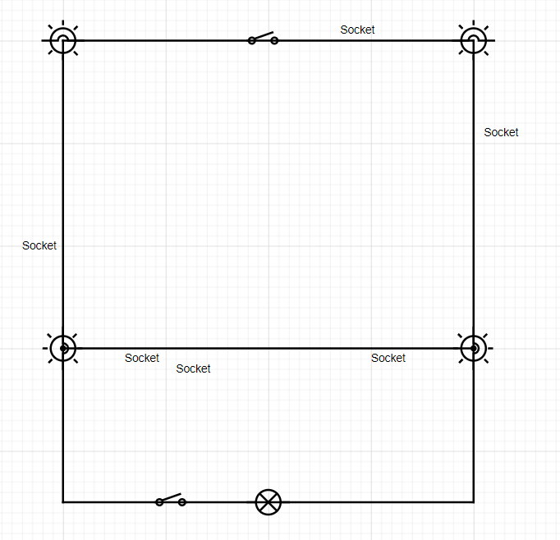

This is a circuit for ***The Living Room*.** 21 Meters of wires were used. It contains 1 Motion Activated Light Bulb (The light bulb on the bottom) 4 Normal Light Bulbs, An Automatic Switch that responds to commands, A Fancy Switch and 6 Electrical Sockets. The circuit with the motion activated light bulb will be in a separate circuit because whenever you want to turn on/off the lights manually, not all the lights will turn on/off. **This room costs 31.250 JD**

***Kitchen Circuit:***

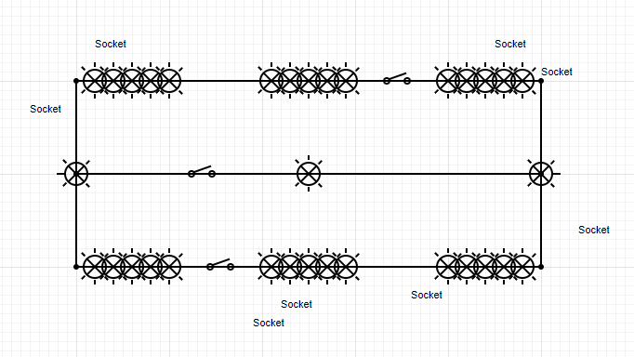

This is a circuit for ***The Kitchen*.** 19 Meters of wires were used. It contains 6 LED Light Bulbs (Each 5 light bulbs paired together are considered 1 LED light bulb), 3 CFL Light Bulbs, 3 Fancy Switches and 8 Electrical Sockets. **This room costs 37.250 JD**

***Bedroom Circuit:***

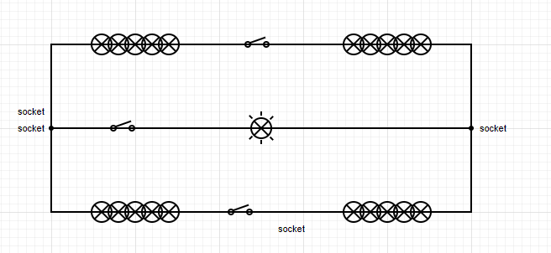

This is a circuit for ***The Bedroom***.19 Meters of wires were used. It contains 4 LED Light Bulbs (Each 5 light bulbs paired together are considered 1 LED light bulb), 1 Normal Light Bulb, 3 Fancy Switches and 4 Electrical Sockets. **This room costs 29.75**

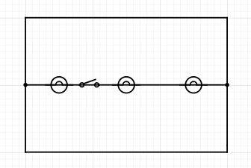***Bathroom Circuit:***

This is a circuit for ***The Bathroom***.13 Meters of wires were used. It contains 3 CFL Light Bulbs and 1 Fancy Switch. **This room costs 16.75**

**The Total Cost is 115 JD**