**Topic** Collecting and documenting scientific data

**Objective**

Enhance students’ ability to incorporate the skills they learn in school with real-life examples. Students will research substances and foods, identify some of their properties and illustrate their importance in improving our lives.

**Team:**

Student’s Names:

1. Omar Alsumrain

2. Carol Alamat

3. Salma alesamy

4. ………………………………………………

5. ………………………………………………

**Selected Title/ Theme:**

Interdisciplinary project

**Resources:**

List of the resources used, please copy and paste the URL of used resources here:

1. <https://www.nutritionix.com/> ( for bio)

2. All chemistry sources are on the powerpoint

3. ………………………………………………………………………………………………

**Your Submission:**

1. Submission document: uploaded to all subjects on LMS as a word file / PDF file by one team member only.
2. All documents/ outcomes mentioned in the task document.



(Double click to open file)

Bio:

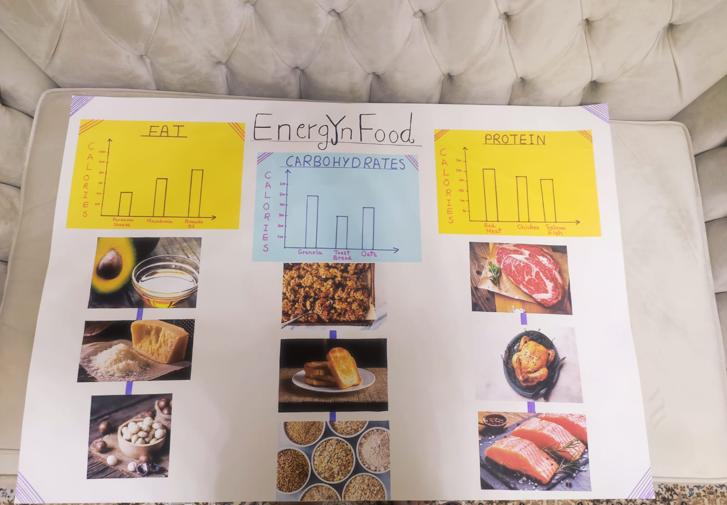

Math: given to teacher by hand