SUN
The sun blasted out a super powerful X-class flare on Friday afternoon (March 3), and a NASA spacecraft captured footage of the dramatic event.
The Solar Flare an intense burst of high-energy radiation — erupted Friday at 12:52 p.m. EST (1752 GMT). It registered as an X2.1, NASA official said, meaning it was particularly intense. (Solar scientists categorize potent flares into three categories, with C being the weakest, M being medium-strength and X the most powerful. The power of Friday's flare is on full display in footage captured by NASA's Earth-orbiting Solar Dynamics Observatory (SDO), which has been studying the sun in detail since 2010.
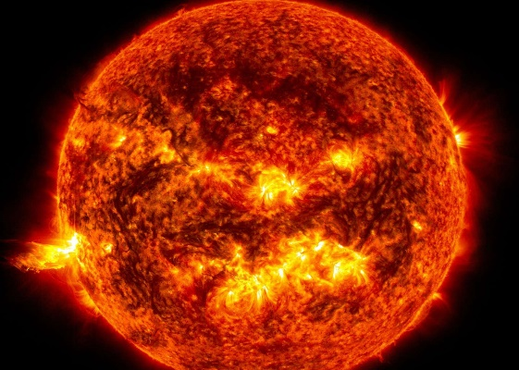

BLACK HOLE

he event horizon is the spherical outer boundary of a black hole loosely considered to be its "surface."
It is the point, according to NASA(opens in new tab), that the gravitational influence of the black hole becomes so great that not even light is fast enough to escape it. As a result of the fact that Albert Einstein's theory of special relativity tells us that no signal can exceed the speed of light in a vacuum (c) humanity can never hope to obtain a signal from the one-way boundary that is an event horizon.
As such event horizons effectively act as cosmic gatekeepers preventing us from ever directly observing the secrets that lie at the heart of black holes. Yet they can reveal a great deal about the environment around them.

MOON

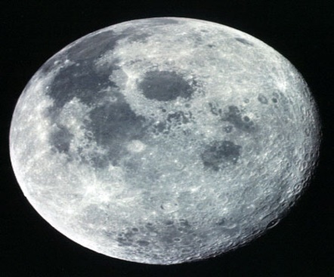
Earth's Moon is the only place beyond Earth where humans have set foot. The brightest and largest object in our night sky, the Moon makes Earth a more livable planet by moderating our home planet's wobble on its axis, leading to a relatively stable climate. It also causes tides, creating a rhythm that has guided humans for thousands of years. The Moon was likely formed after a Mars-sized body collided with Earth. Earth's Moon is the fifth largest of the 200+ moons orbiting planets in our solar system. Earth's only natural satellite is simply called "the Moon" because people didn't know other moons existed until Galileo Galilei discovered four moons orbiting Jupiter in 1610.NASA currently has three robotic spacecraft exploring the Moon – Lunar Reconnaissance Orbiter and the twin ARTEMIS spacecraft (not to be confused with NASA's new Artemis program to send astronauts back to the Moon).

