Psychology

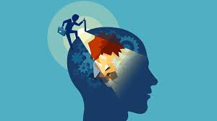

Student Work :

Mirna f.haddad

By Teacher : maisa

*Psychology* is the scientific study of the mind and behavior. Psychologists are actively involved in studying and understanding mental processes, brain functions, and behavior.

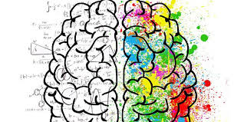

What are the 4 main types of psychology?

There are different types of psychology, such as **cognitive, forensic**, **social, and developmental psychology**.

Is psychology a good career?

Mental awareness has increased so as has the careers in **psychology**.

Projected to grow at the rate of **14%** year-on-year.

Can psychologists read minds?

So, while your psychologist can't read your mind, **they are trained to be aware** of many small cues.

**These cues give them insight into a** person's mental state.

What are the 5 basic psychology?

**The five major perspectives in psychology are** biological, psychodynamic, behavioral, cognitive and humanistic.

What are the *7 principles* of psychology**?**

1. **Movement and Learning. ...**
2. **Emotional States. ...**
3. **Physical Environment. ...**
4. **Social Interaction and Competition. ...**
5. **Motivation and Engagement. ...**
6. **Commitment and Consistency. ...**
7. **Critical Thinking and Memory Recall.**

**The trusted reference:**

**https://www.psychologytoday.com/intl**