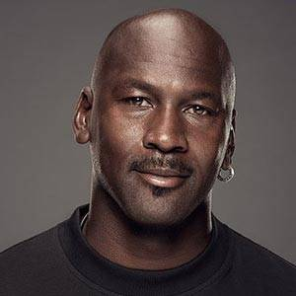

**Michael Jordan**

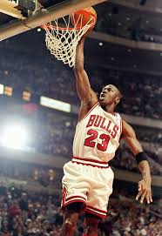Michael Jordan is considered by most experts to be the greatest basketball player of all-time. He played collegiately at the University of North Carolina, where he helped that team win an NCAA championship in 1982 and also won gold at the Pan American Games in the same year. In 1984, Jordan led the United States to an Olympic gold medal. Turning to professional basketball after his junior year in college, he became the greatest player in the NBA (National Basketball Association). In 1991, Jordan finally achieved his greatest thrill, leading the Chicago Bulls to an NBA Championship, and completing his Triple Crown of titles – NCAA, NBA, and Olympic. Jordan eventually led the Bulls to six NBA titles (1991-1993, 1996-1998). In 1992, Jordan also played on the which won the basketball gold medal at Barcelona. He could also have played in 1996 but chose not to do so. Jordan retired briefly at the beginning of the 1993-94 NBA season, taking a short fling at playing minor league baseball, but returned to basketball at the end of the 1995 season. He retired again after helping the Chicago Bulls win their sixth NBA title in the spring of 1998. However, Jordan came out of retirement to play for the Washington Wizards in the 2001-03 NBA seasons.