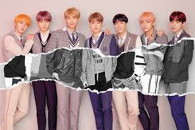The korean pop

Done by: Joud

Grade:7B

**WHAT IS THE K POP?**

Its a form of [popular music](https://en.wikipedia.org/wiki/Popular_music) originating in [South Korea](https://en.wikipedia.org/wiki/South_Korea) as part of [South Korean culture](https://en.wikipedia.org/wiki/South_Korean_culture). It includes styles and genres from around the world, such as [pop](https://en.wikipedia.org/wiki/Pop_music), [hip hop](https://en.wikipedia.org/wiki/Hip_hop_music), [R&B](https://en.wikipedia.org/wiki/Contemporary_R%26B), [rock](https://en.wikipedia.org/wiki/Rock_music), [jazz](https://en.wikipedia.org/wiki/Jazz), [gospel](https://en.wikipedia.org/wiki/Gospel_music), [reggae](https://en.wikipedia.org/wiki/Reggae), [electronic dance](https://en.wikipedia.org/wiki/Electronic_dance_music), [folk](https://en.wikipedia.org/wiki/Contemporary_folk_music), [country](https://en.wikipedia.org/wiki/Country_music), [disco](https://en.wikipedia.org/wiki/Disco), and [classical](https://en.wikipedia.org/wiki/Classical_music) on top of its [traditional Korean music](https://en.wikipedia.org/wiki/Traditional_Korean_music) roots.

TOP 5 GROUPS:

BTS

Black pink

Twice

STRAY KIDS

**WHAT IS K POP FANDOM?**

This young demographic has transformed K-pop into a social media phenomenon. Fans take to social media platforms, such as Twitter, Instagram, and TikTok, to express their love for their favorite K-idols and to access original content, including photography and translations of K-pop material into their own language.

**SOME OF FANDOM NAMES**

BTS=ARMY

BLACKPINK=BLINK

TWICE=ONCE

STRAY KIDS=STAY

**WHY DO PEOPLE LOVE K POP?**

Their songs where you can cry, vibe on, rock with, sing so loud with, learn a dance with, and so much more. In general, **their songs just makes me happy** and that is one thing special from them

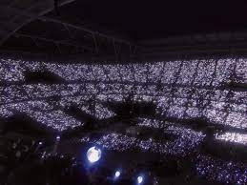

**How has K-pop change the world?**

K-Pop idols and their music have **positively contributed to South Korean diplomacy, economy, human rights movements, and the country's global status** for decades, especially during times of high political tension.

**To the dark side of the K-Pop world and the obsession of some K-Pop fans**

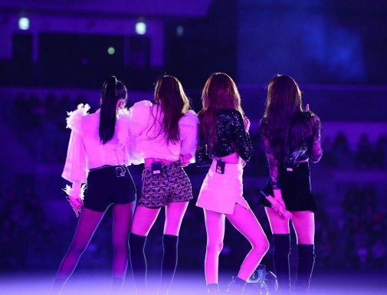**Mistreatment, suicide, slave labor contracts, grueling training schedules, “no dating” clauses, sexual assault, and sexualization of minors** by K-pop agencies cannot go unnoticed. While some groups promote the image of being antifragile, the entire K-pop industry rests on fragile foundations

**What is the positive effect of K-pop?**

Many people’s mental health and morals have been positively impacted by the messages in several K-pop songs and K-dramas. As a result of seeing how their favourite celebrities can speak numerous other languages, many people have begun learning the language and several other languages thus becoming more confident.

**How does K-pop influence the youth today?**

K-Pop has an impact that changes the attitudes or habits of teenagers from being non-consumptive to consumptive, and also changes the attitude of teenagers to be more selective in spending the money they have, besides that, teenagers also become individuals.

**Why is K-pop important to Korea?**

South Korea’s K-pop culture and music industry have become increasingly popular and thus have allowed the propagation of the music genre to many foreign nations through the Korean wave, also known as Hallyu. The K-Pop industry generates about $10 bn for the country each year, according to estimates.

<https://www.wionews.com/korean-wave-has-become-a-free-therapy-for-the-fans-how-k-pop-and-k-dramas-are-having-a-positive-influence-on-many-561953>

<https://en.m.wikipedia.org/wiki/K-pop>

<https://www.vam.ac.uk/articles/k-pop-fandom#:~:text=This%20young%20demographic%20has%20transformed,material%20into%20their%20own%20language>.