**Question 1 :**

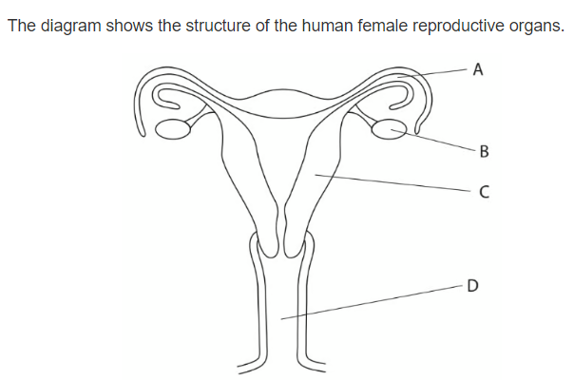

x

* Which letter represent the site of fertilization A
* Which letter shows were the fetus usually develop d
* Name organs :

B : ovary

A : oviduct

C : uterus

* Draw an x on the diagram to show where implantation takes place .
* State what is meant by the term menstruation .

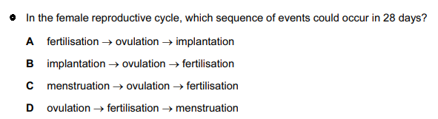menstruation is the process in which the egg is released from one of the ovaries in adult women and if it doesn’t get fertilized then bleeding will occur if it does get fertilized zygote ill form

d

**Question 2 :**

1. Khalil is one of three boys , his parents are expecting another child and they are certain it will be a girl . Explain why they are wrong ? *( 1 marks )*

The egg always carries chromosone x and the sperm could either carry x or y so there is a 50% chance for both of the genders

1. Copy and complete the diagram to show how the sex of the baby is inherited.

*( 4 marks )*

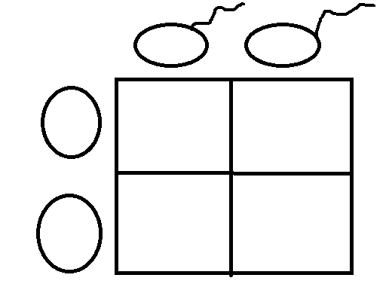

xy

x

y

xx

xy

x

xx

xy

x

**Question 3 :**

Arrange these objects in size order, starting with the largest. *( 2 marks )*

Nucleus chromosomes gene cell DNA

Nucleus / cell/chromosomes/DNA/genes

**Question 4 :**

The diagram shows an egg, a sperm and a fertilized egg. *( 3 marks )*

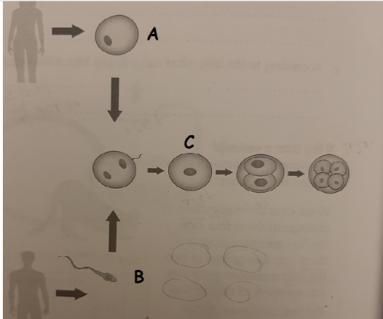Label the diagram to show how genes from each parent get into all an embryo’s cells

fertilisation

A=egg

B=sperm

C= cell

**Question 5 :**

Demonstrate how an egg cell is adapted to its function .

There is a jelly like substance which attracts sperm, the cytoplasm stores fat to feed the embryo produced, the egg has a nucleus which carries genes.