**Global warming**

**Grace Estefan Grade 7 B**

**Global warming** is the long-term heating of Earth's surface observed since the pre-industrial period (between 1850 and 1900) due to human activities, primarily fossil fuel burning, the current rise in global average temperature is more rapid than previous changes which increases heat-trapping greenhouse gas levels in Earth's atmosphere.

Though this warming trend has been going on for a long time, its pace has significantly increased in the last hundred years. As the human population has increased, so has the volume of fossil fuels burned. Fossil fuels include coal, oil, and natural gas, and burning them causes what is known as the “greenhouse effect” in earth’s atmosphere.

**The greenhouse effect** is when the sun’s rays penetrate the atmosphere, but when that heat is reflected off the surface cannot escape back into space. Gases produced by the burning of fossil fuels prevent the heat from leaving the atmosphere. These greenhouse gasses are carbon dioxide, chlorofluorocarbons, water vapor, methane, and nitrous oxide. The excess heat in the atmosphere has caused the average global temperature to rise overtime.

**Global warming** has presented another issue called climate change, climate change refers to changes in weather patterns and growing seasons around the world. It also refers to sea level rise caused by the expansion of warmer seas and melting ice sheets and glaciers. Global warming causes climate change, which poses a serious threat to life on earth in the forms of widespread flooding and extreme weather.

The devastation that climate change is causing and will continue to cause means it is code red for humanity.

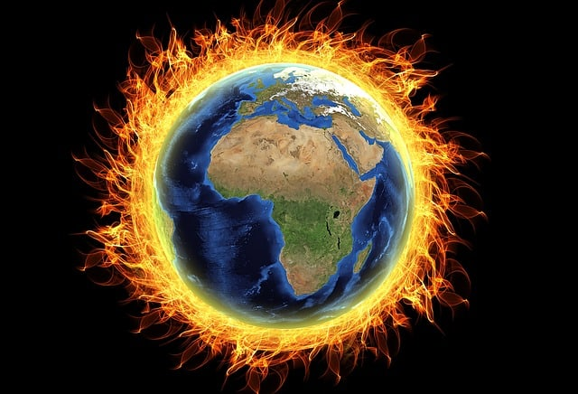Everyone can help limit climate change. From the way we travel, to the electricity we use and the food we eat, we can make a difference. Start with these seven actions to help tackle the climate crisis.

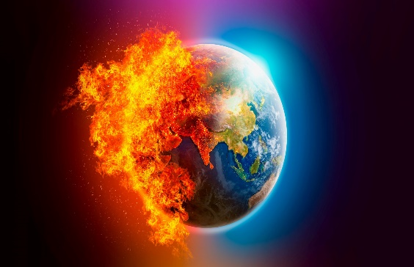

1. Save energy at home.
2. Walk, cycle or take public transport.
3. Consider your travel.
4. 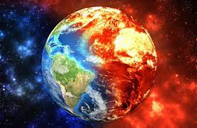Throw away less food.
5. Reduce, reuse, repair & recycle.
6. Change your home's source of energy.
7. Switch to an electric vehicle.