Introduction

Polar bears live all round the Arctic, in northern Canada, Alaska, Greenland and Russia In winter ice covers the Arctic ocean. The sea water freezes, too Polar bears hunt for food on the sea ice. In summer, when the sea ice melts, they live on land but there is little food for them. They wait for the autumn when the sea freezes and they can go hunting again.

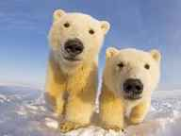

Appearance

Polar bears are the largest kind of Bears . The male is about 2.5m tall and weighs around 500kg. the female is smaller, about 2m tall and weighs about 250kg their thick, white fur insulates them from cold. Their feet are large and furry and they can walk across the snow easily. They can swim well, too, because their feet are partly webbed.

Diet

Polar bears hunt the seals that live under the ice in the Arctic Ocean . seals make holes in the ice and they come up to breathe. The Polar bears waits patiently by the hole. When the seal comes up, the polar bear tries to seize it in its powerful jaws.

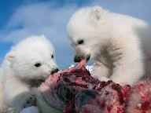

Reproduction

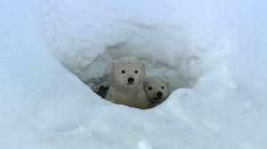In the winter, female bears make dens under the deep snowdrifts. Here the cubes are born. The mother bear keeps them warm and fed for several months without ever leaving them. When they are bigger, They go outside. The mother bear teaches them to hunt on the ice floes.

Threats

Loss of sea ice because of climate change is the main threat to polar bears, but pollution from industry and oil spills also threaten them. In Russia a new Arctic park has been created. Here polar bear will live in safety protected from industrial activity.

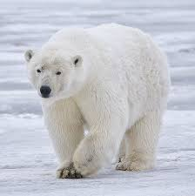

This is a female polar bear .

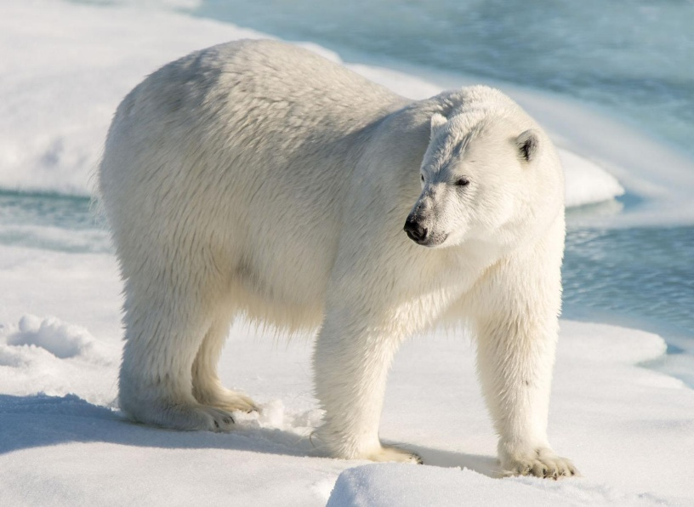This is a male polar bears .